**Guvi-Project-01**

**Application Deployment**

(Deploy the given react application to a production ready state)

**Task: Application:**

Clone the below mentioned repo and deploy the application. (Run the application in port [80])

Repo URL: <https://github.com/sriram-R-krishnan/devops-build>

**Step 1: Setting up the local environment.**

1.1 Install the necessary application on the local environment

Git (for version control) - local

Docker (for containerization) -local

Jenkins (CI/CD) – EC2

AWS CLI (to interact with AWS services) – EC2

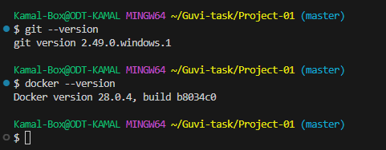

* 1. Clone the repository

git clone <https://github.com/sriram-R-krishnan/devops-build\>

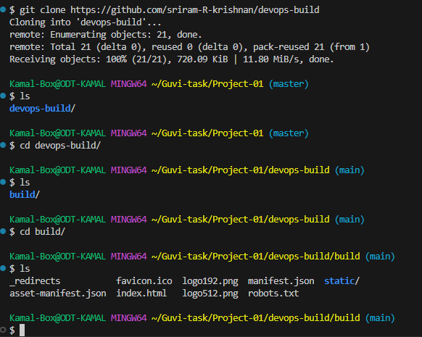

**Docker**:

Dockerize the application by creating a Dockerfile.

Create a docker-compose file to use the above image

**Step 2: To create a dockerfile**

Since the given application is a pre-built React static site, I am using NGINX to serve it.

2.1 Create a new file named Dockerfile and add the following content, inside the build folder.

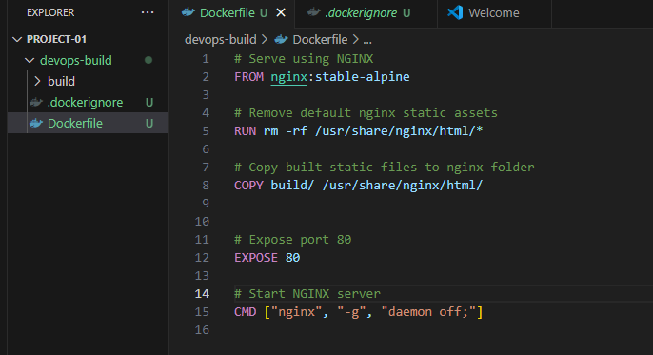

2.2 Create .dockerignore file to avoid copying unnecessary files

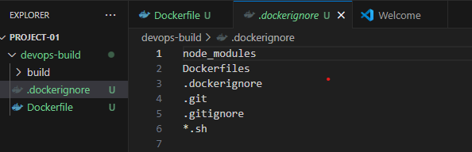

2.3 Build and run the Docker Container

: docker build -t react-site .

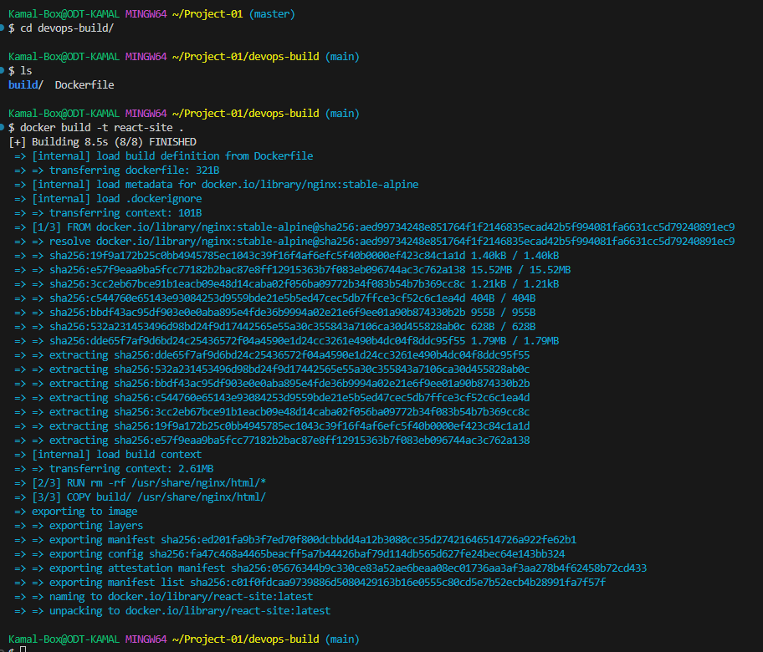

2.4 Check the created docker image

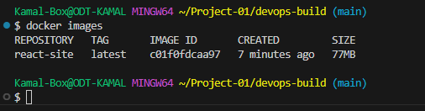

2.5 Run the container

: docker run -d -p 80:80 react-site

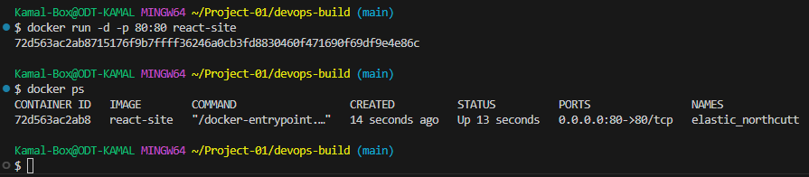

2.6 Now access the site at <http://localhost:80>

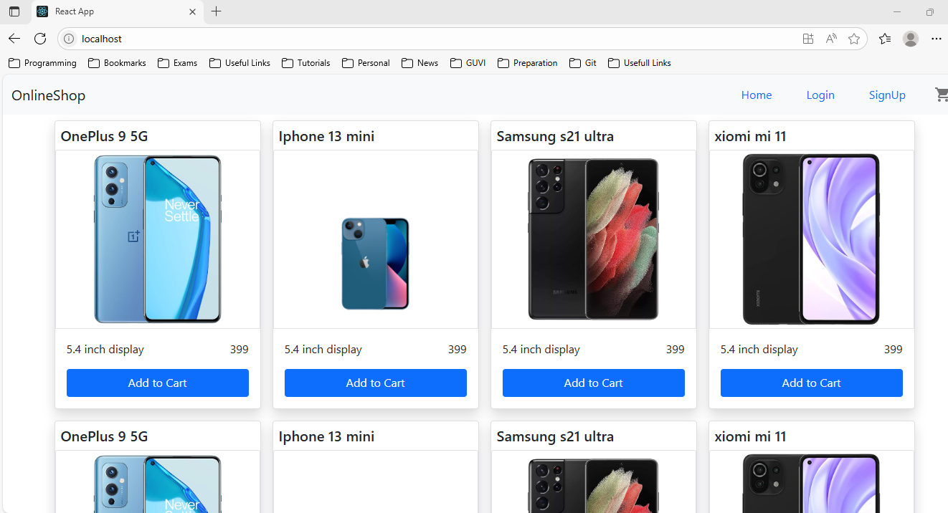

2.7 Add a dockercompose.yml

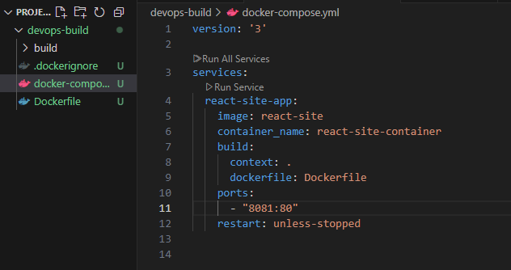

2.8 Run using Docker Compose

: docker compose up –build -d

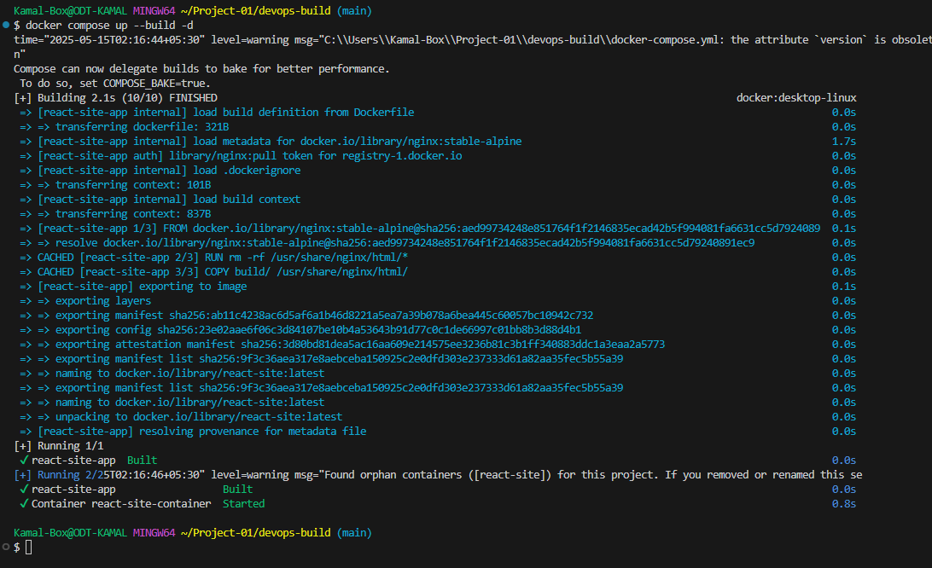

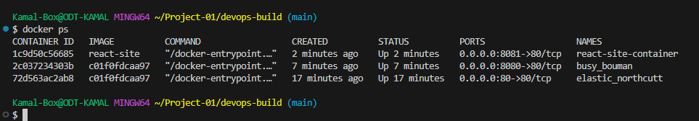

**Step 3: Bash Scripting**

Write 2 scripts

Build.sh – for building docker images

Deploy.sh – for deploying the image to servers

Build.sh script will build the docker image and push it to docker hub (dev and prod tags)

3.1 login to dockerhub

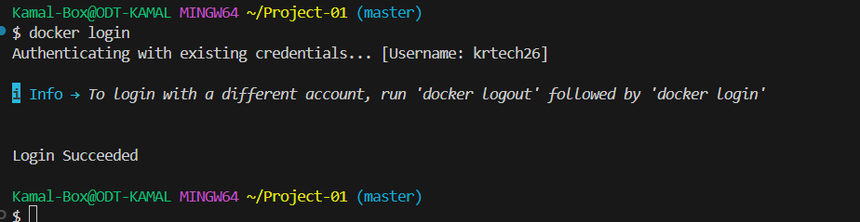

We already have docker application installed on our machine, it taking the existing account.

3.2 Create build.sh in project root directory and make it executable permission then run it. Make sure you are creating two repo for “dev” and “prod”

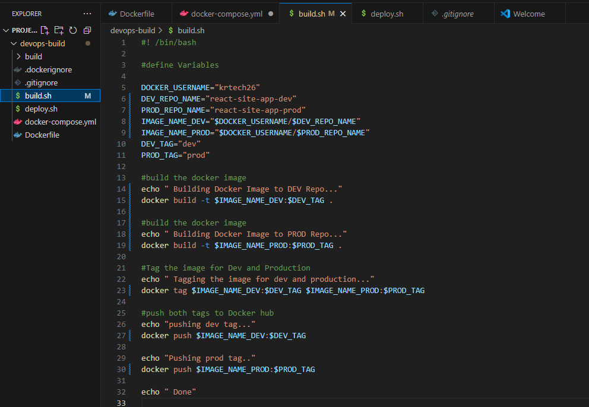

Chmod +x build.sh gives executable permission

./build.sh run the file

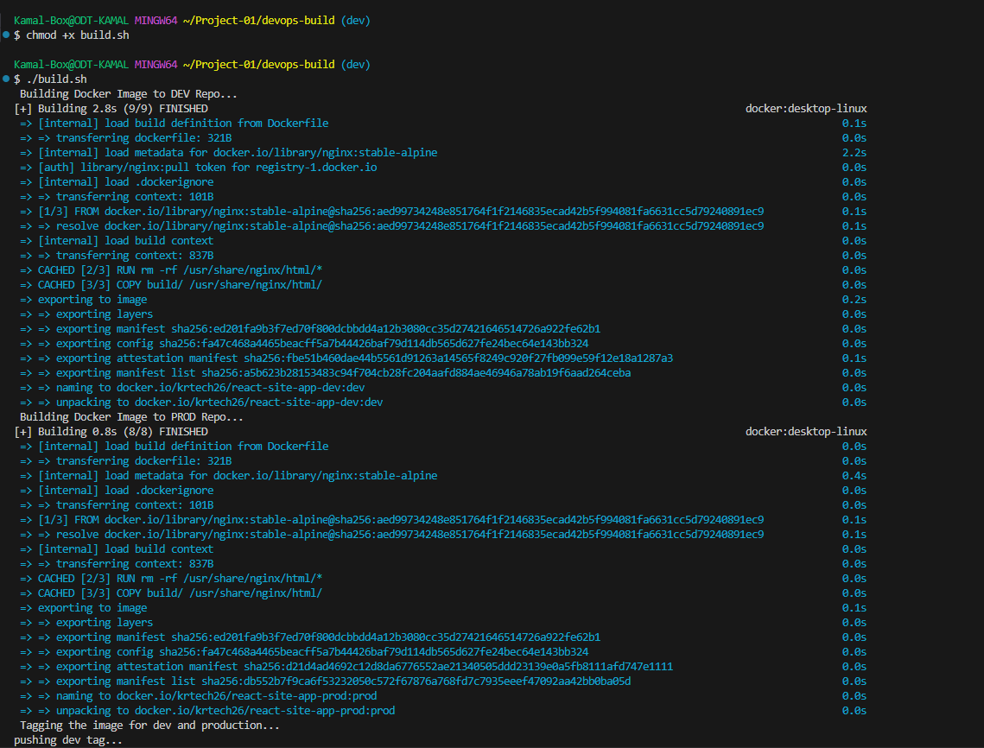

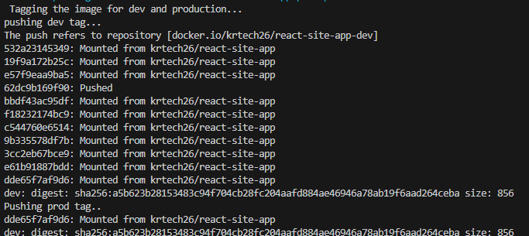

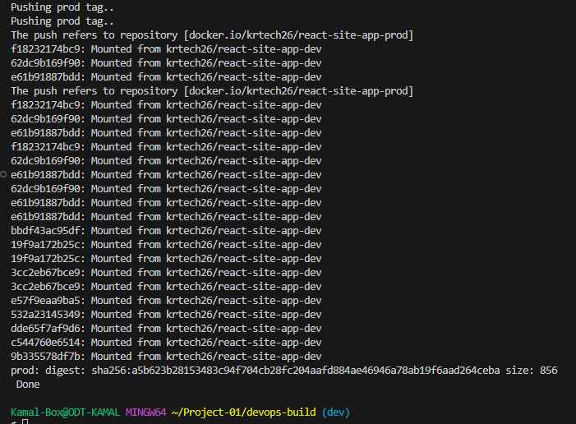

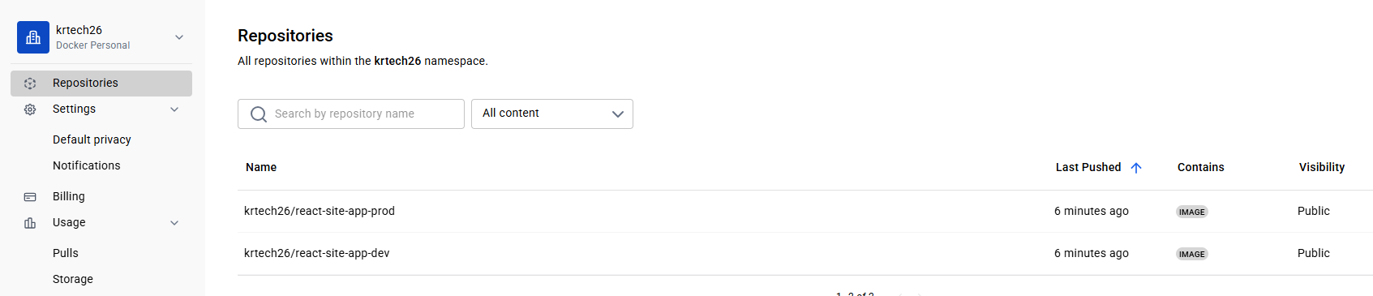

Once the build.sh executed, repo “react-site-app-dev” and “react-site-app-prod” has been created in Dockerhub and “prod” and “dev” tag has been assigned.

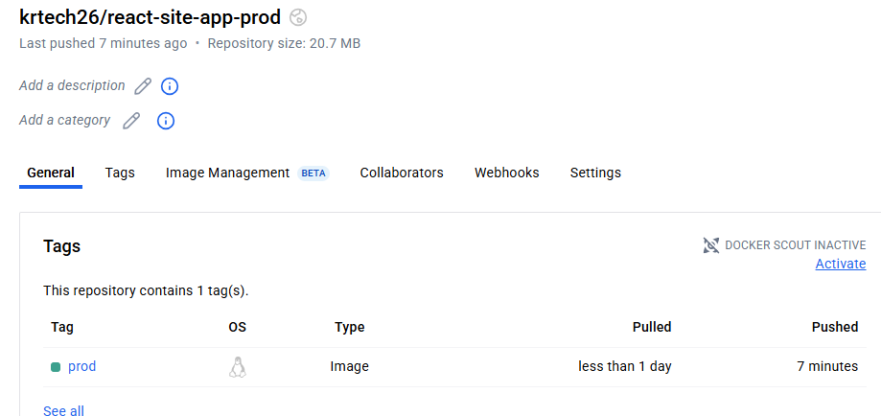

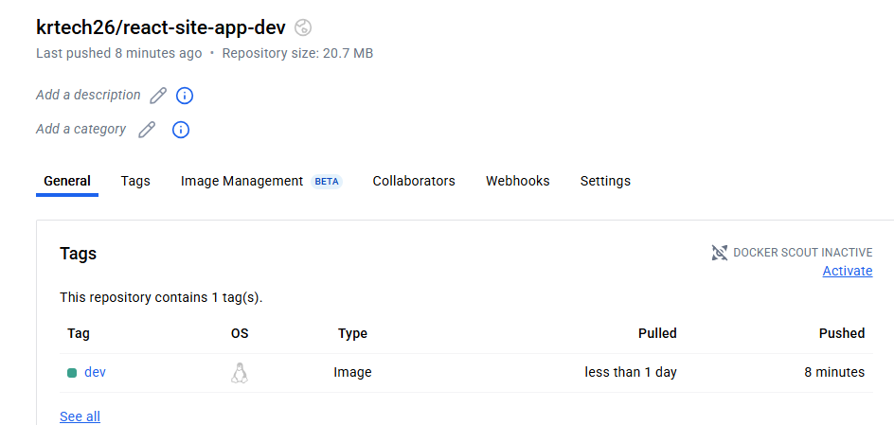

3.3 create a deploy.sh to deploy the image

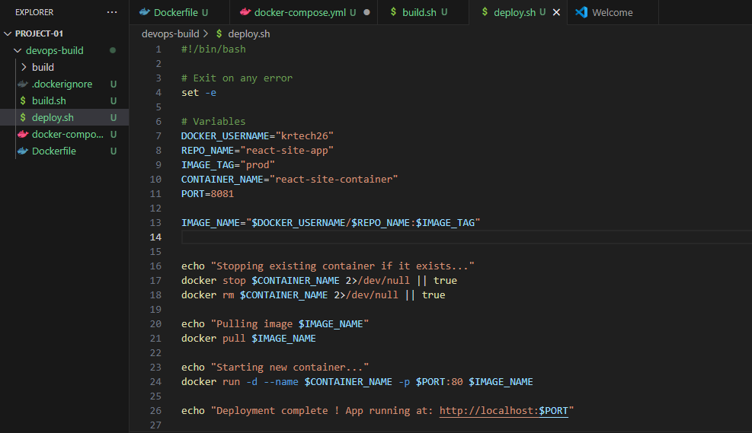

Chmod +x deploy.sh to give executable permission

./deploy.sh to run the application

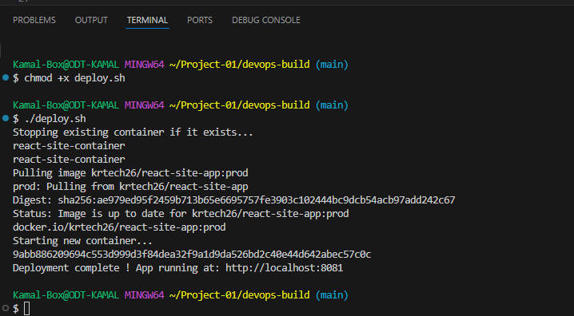

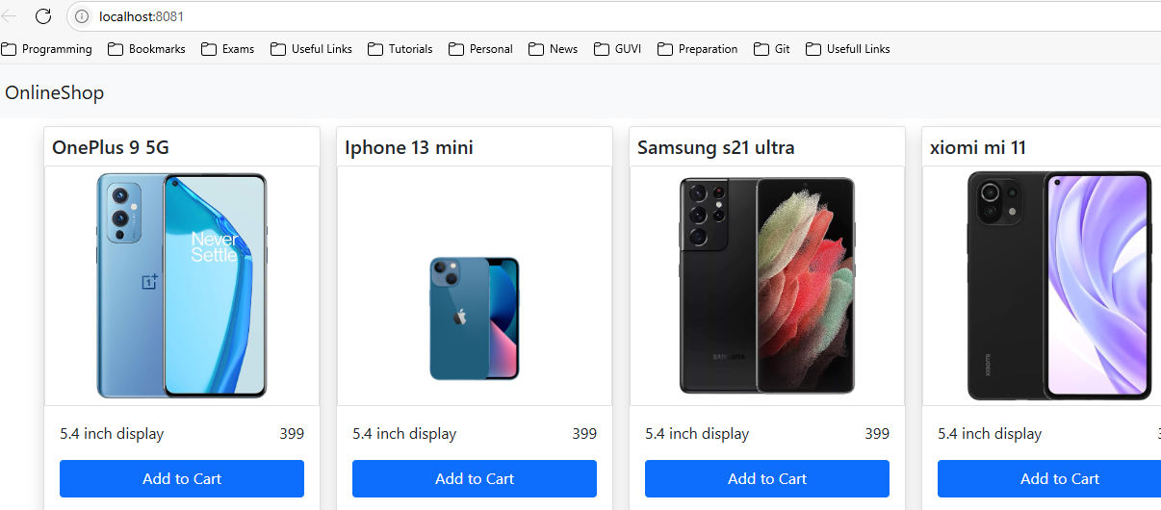

Now site has been reachable through Deploy.sh

**Step 4: Version Control**

Push the code to github to dev branch (use dockerignore & gitignore files)

Note: use only CLI for related git commands

4.1 first create a. gitignore file in the project root

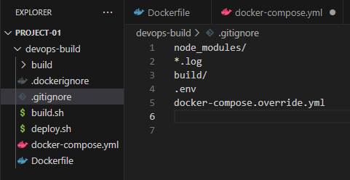

4.2 Push the code to github to dev branch

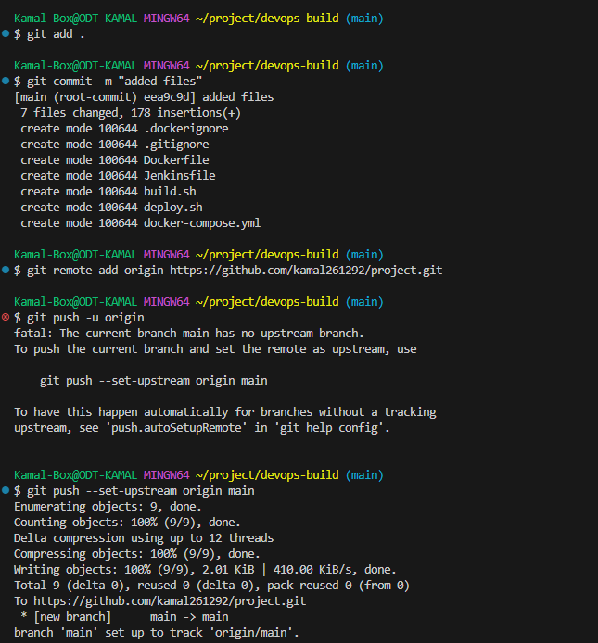

Now create a “dev” branch using ‘main’ branch

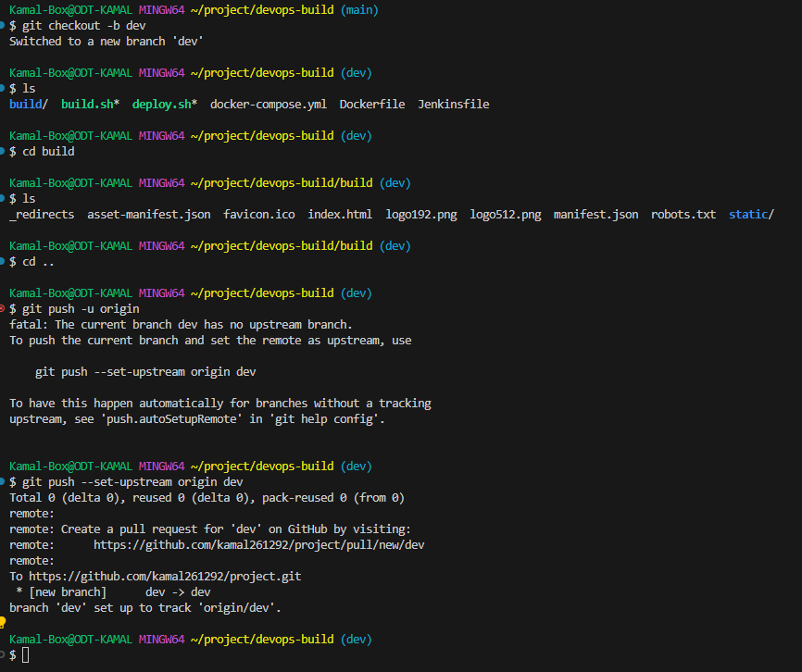

**Step 5: Docker Hub**

Create 2 repos “dev” and “prod” to push images

“prod” repo must be private and “dev” repo can public

As we already created the repo’s using build.sh we need to change the default permission on “prod” repo.

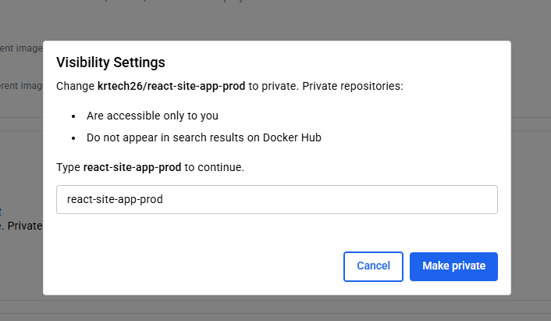

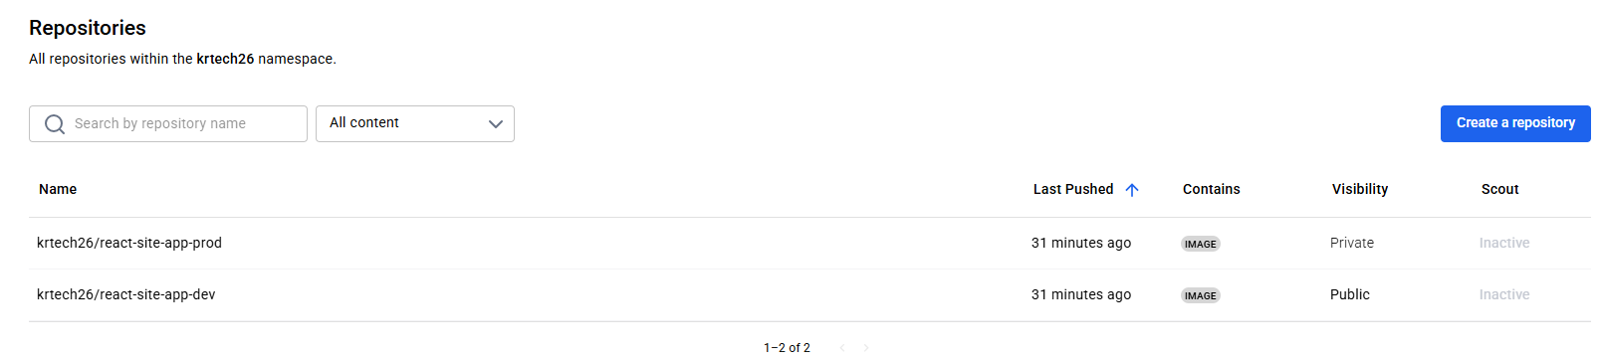

**Step 6: Jenkins**

* 1. Install and configure Jenkins build step as per needs to build, push and deploy the application

Create a EC2 instance to install Jenkins



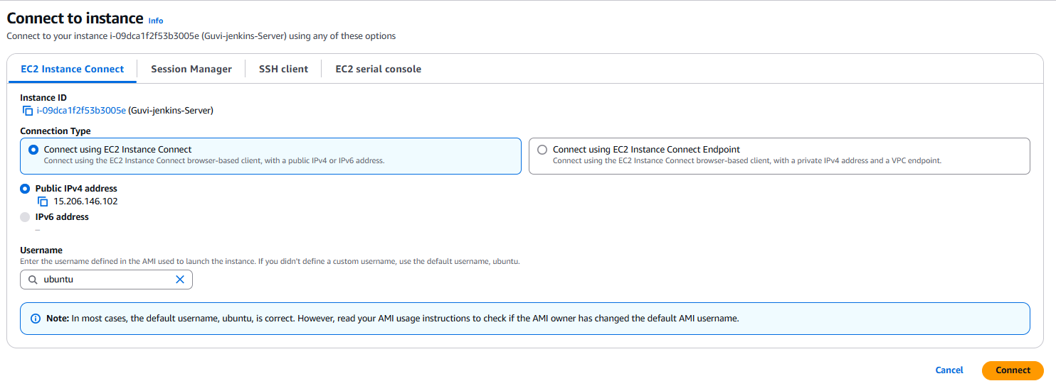

Run **sudo su** – get into the root user

Run **apt update** – download the updates

For the installation on Jenkins it required java openjdk

**sudo apt install openjdk-17-jdk -y**

to check the version **java --version**

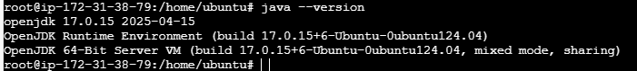

**Add Jenkins Repository & Install Jenkins**

-> Add the repository key:

**curl -fsSL https://pkg.jenkins.io/debian/jenkins.io-2023.key | sudo tee \**

**/usr/share/keyrings/jenkins-keyring.asc > /dev/null**

-> Add the Jenkins repository:

**echo "deb [signed-by=/usr/share/keyrings/jenkins-keyring.asc] \**

**https://pkg.jenkins.io/debian binary/" | sudo tee \**

**/etc/apt/sources.list.d/jenkins.list > /dev/null**

-> Update packages and install Jenkins:

**sudo apt update**

**sudo apt install -y jenkins**

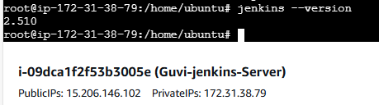

**Start and Enable Jenkins**

**sudo systemctl start jenkins**

**sudo systemctl enable Jenkins**

Check status:

**sudo systemctl status Jenkins**

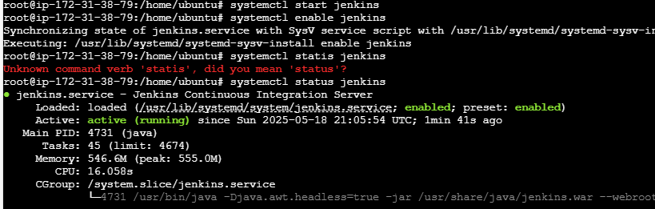

**6.2 Setup Jenkins**

-> Access Jenkins in a browser

**http://<server-ip>:8080 (Enable port 8080 In security group)**

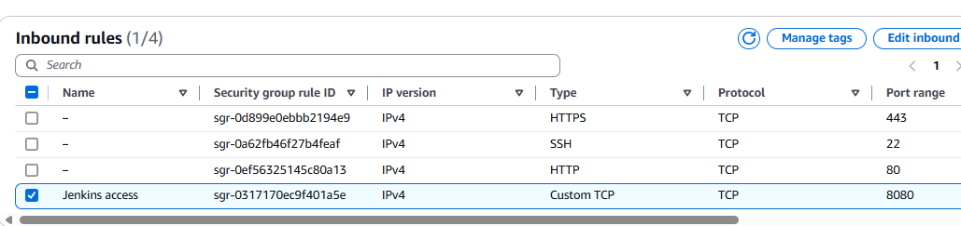

-> Retrieve the initial admin password:

**sudo cat /var/lib/jenkins/secrets/initialAdminPassword**

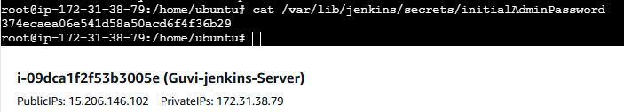

-> Copy and paste the password into the Jenkins setup page.

-> Follow the setup wizard, install recommended plugins, and create an admin user.

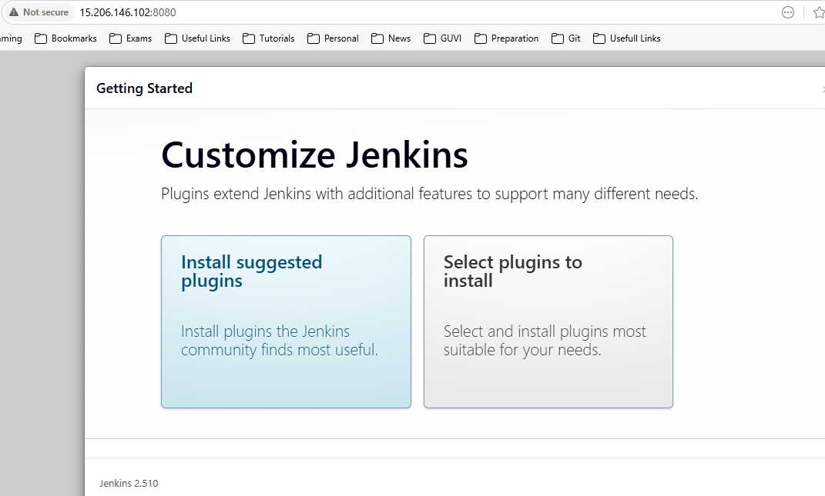

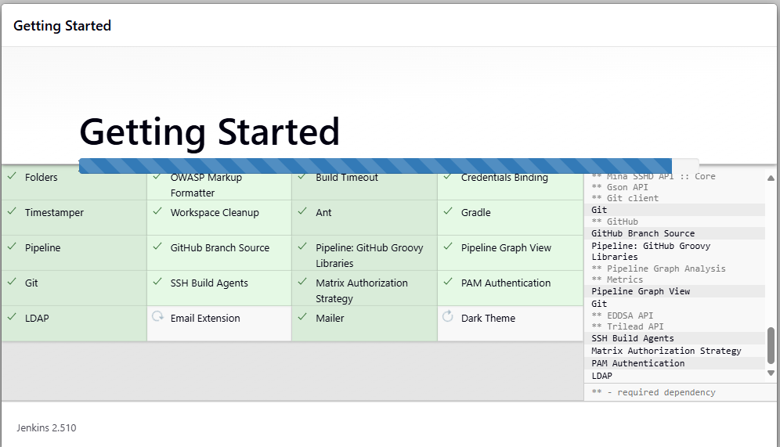

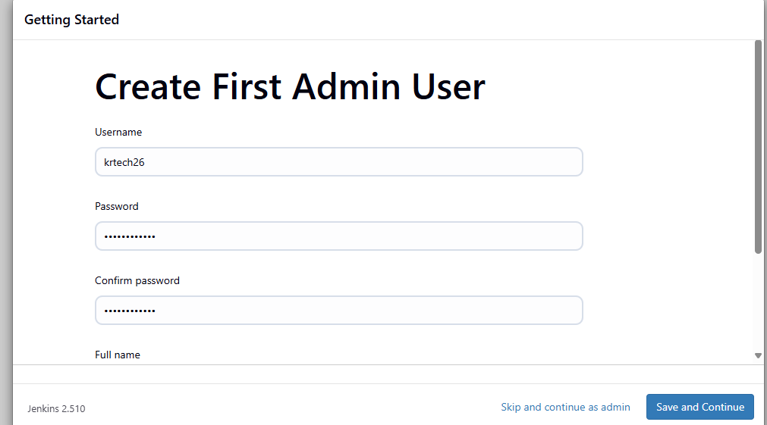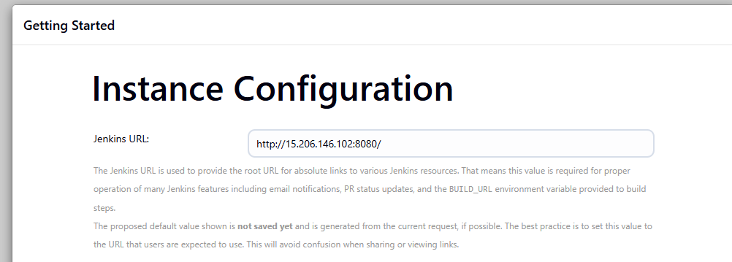

Note: got free swap space issue, so power off the VM and increase the disk size due to that public IP of the Jenkins server changed to **13.201.11.65**:8080

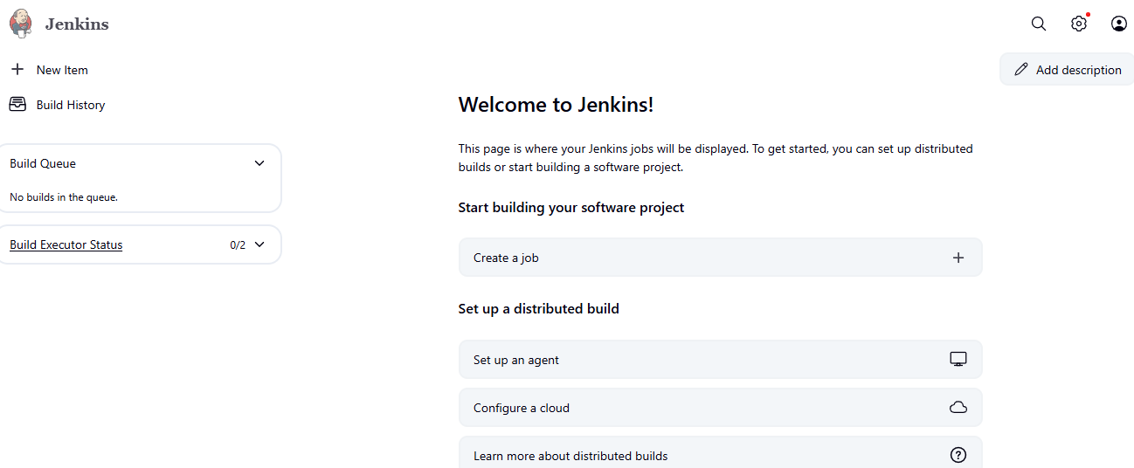

**6.3 Connect Jenkins to the github repo with auto build trigger from both dev and master branch.**

**Jenkins Setup**

* Install Jenkins
* Install these plugins:
  + **Docker Pipeline**
  + **Pipeline**
  + **GitHub Integration Plugin**
  + **GitHub Branch Source Plugin**

Under setting 🡪 Plugins

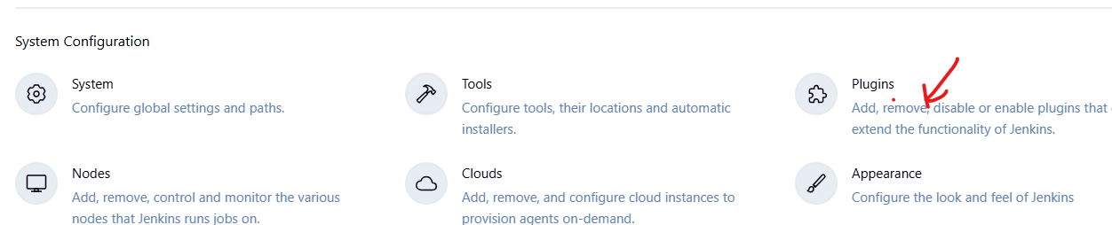

Install the necessary plugin mentioned above.

**6.4 Docker Hub Credentials in Jenkins**

1. Go to **Jenkins > Manage Jenkins > Credentials > (Global)**.
2. Add a new credential:
   * **Kind**: Username with password
   * **ID**: docker-hub-creds (you’ll use this in the pipeline)
   * Add your Docker Hub **username** and **password**

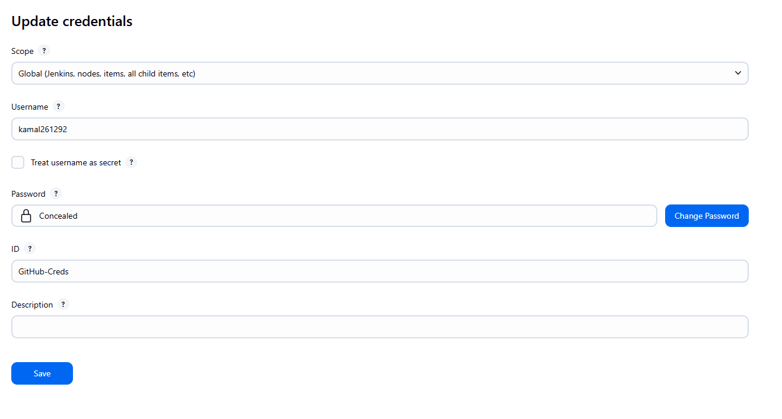

**6.5 GitHub Webhook Setup**

1. Go to your GitHub repo.
2. Go to **Settings > Webhooks > Add webhook**
   * Payload URL: http://<your-jenkins-url>/github-webhook/
   * Content type: application/json
   * Trigger: Just the push event
3. Make sure GitHub is connected to Jenkins using a **GitHub token** in Jenkins credentials if needed.

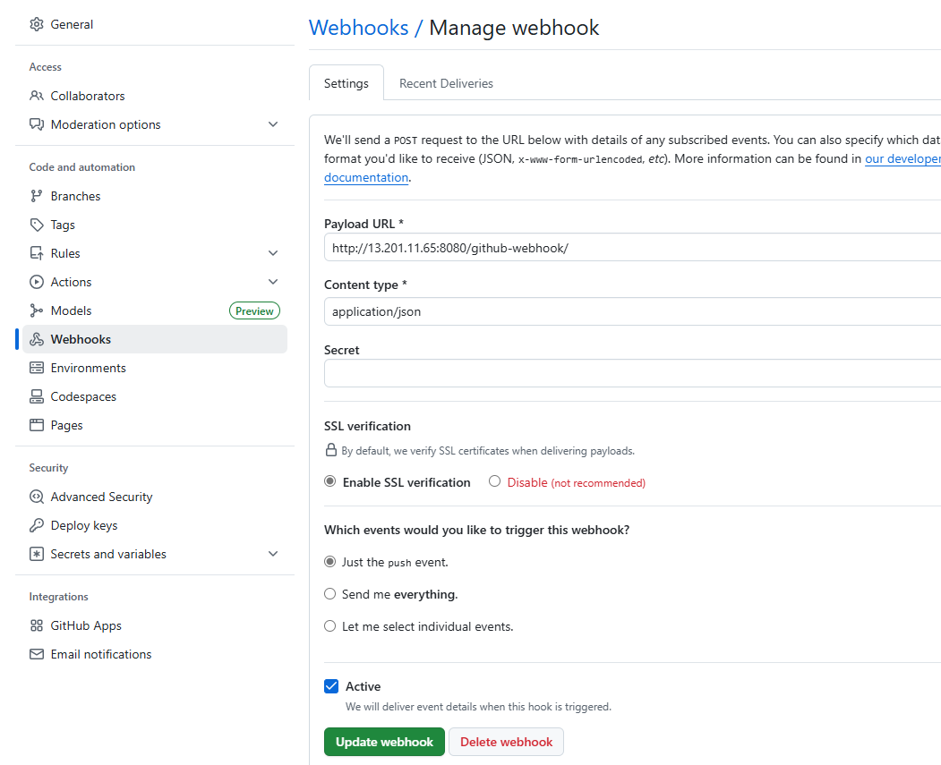

**6.6 Create a Jenkins Multibranch Pipeline Job**

1. Go to Jenkins > New Item
2. Select **Multibranch Pipeline**
3. Under **Branch Sources**:
   * Add your GitHub repo
   * Add credentials (GitHub token if private)
4. Enable **"Discover branches"**
5. Jenkins will now auto-detect dev and master

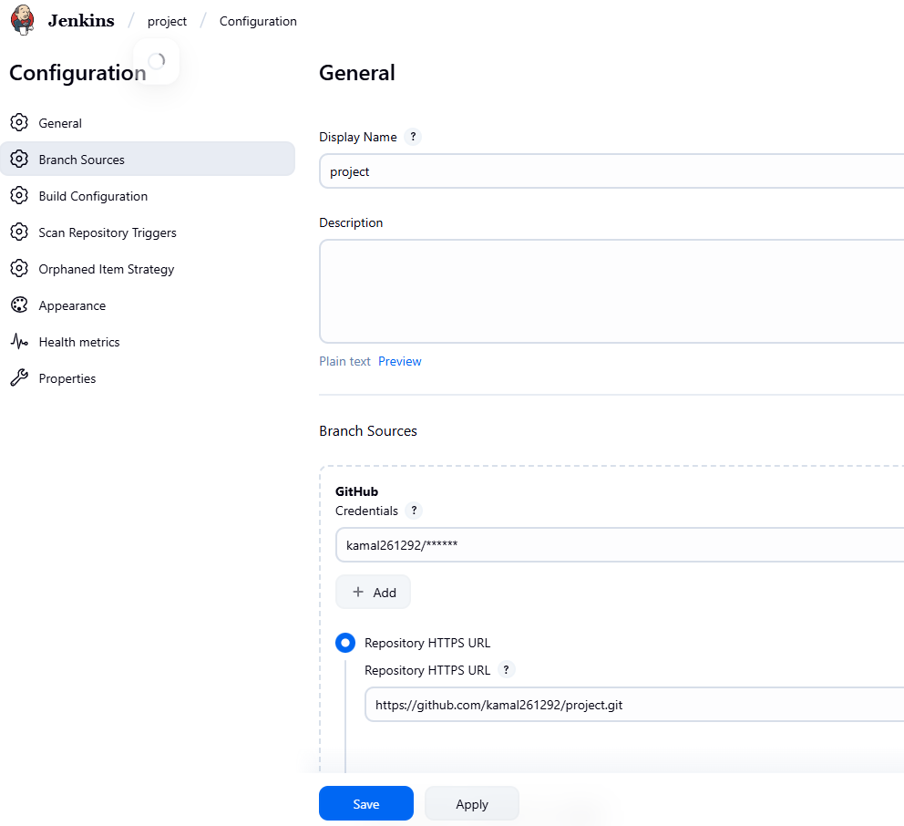

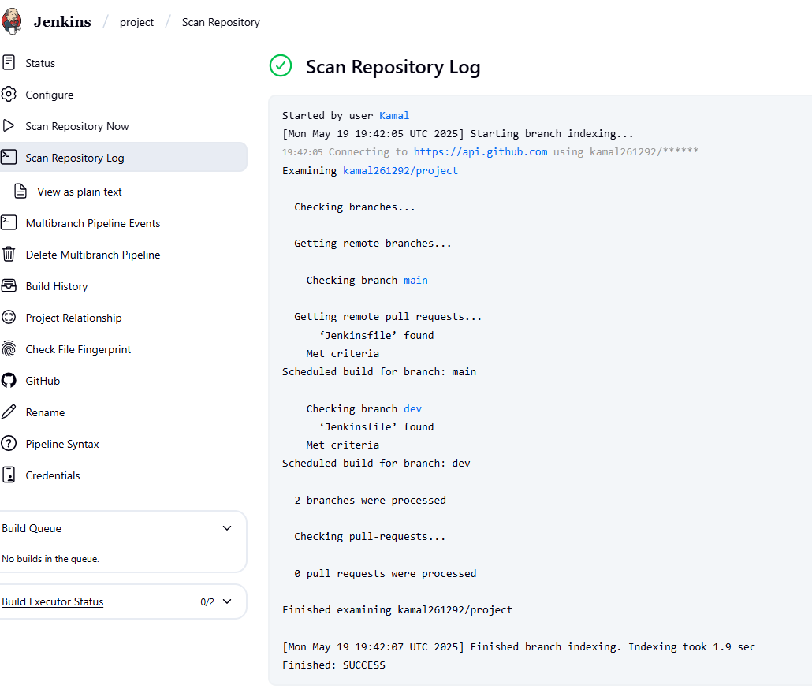

Now Multibranch pipeline has been created and connected with github main and dev branch.

Write a Jenkins file for the mentioned configuration and update in both main and dev branch in github.

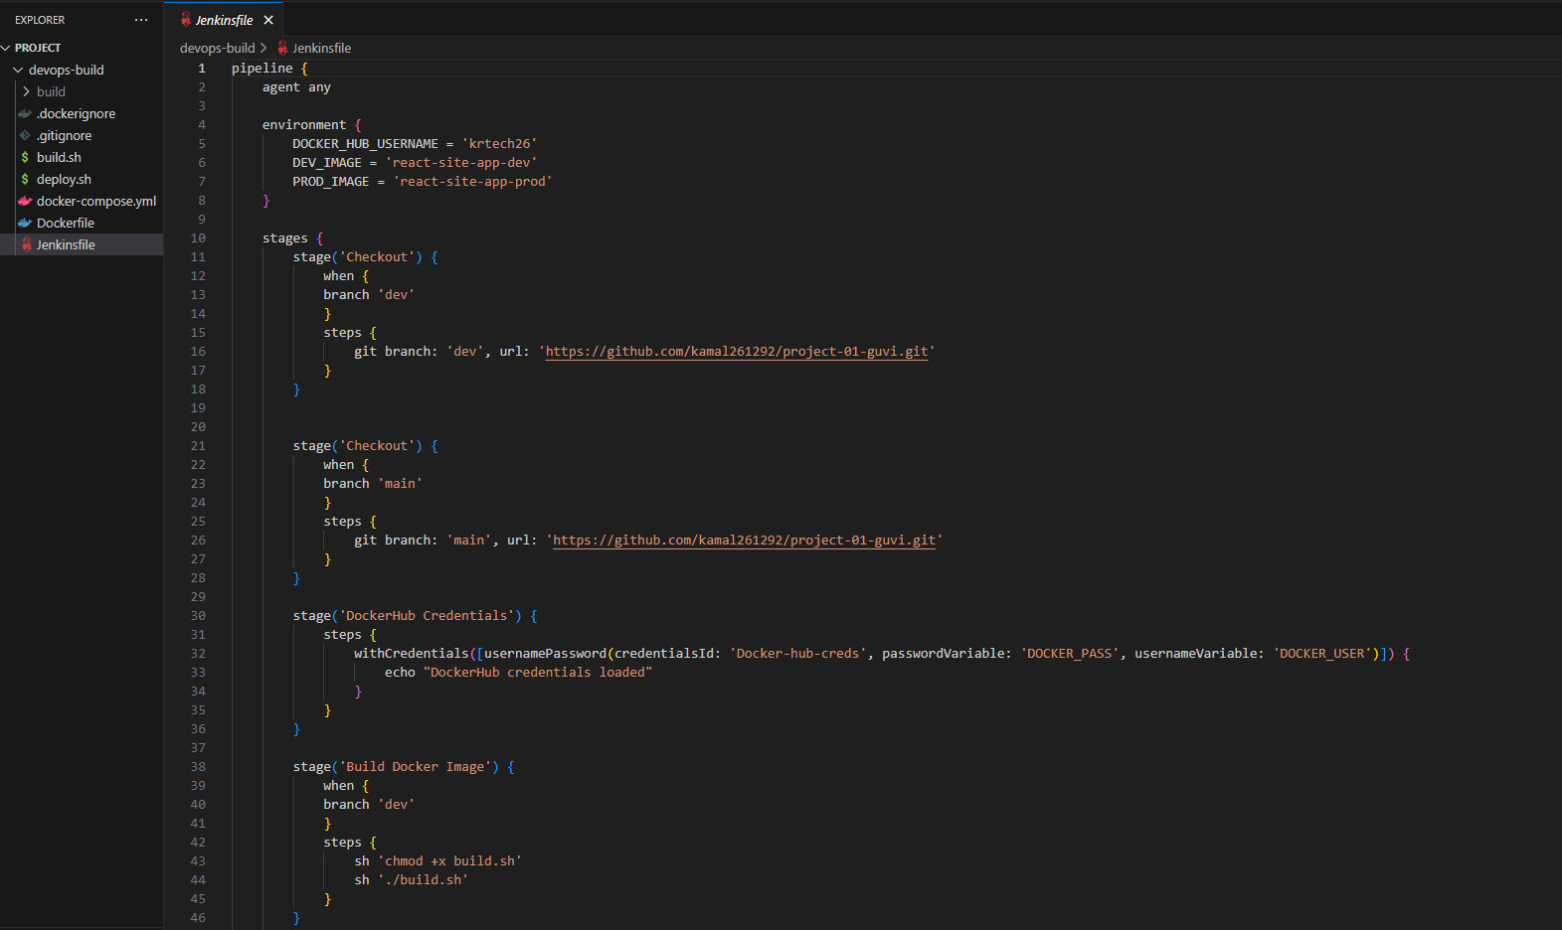

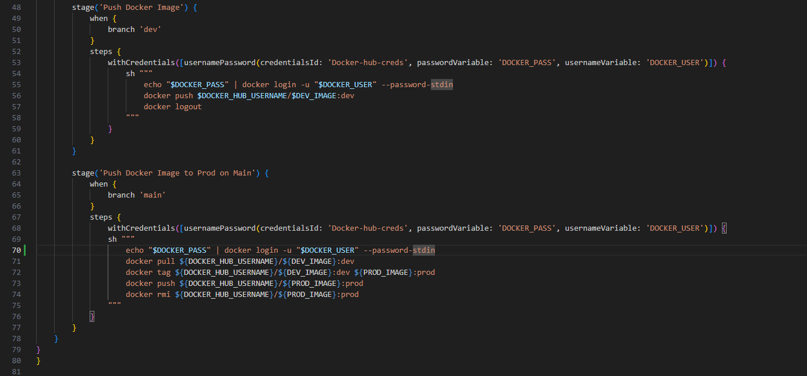

Now run the build.

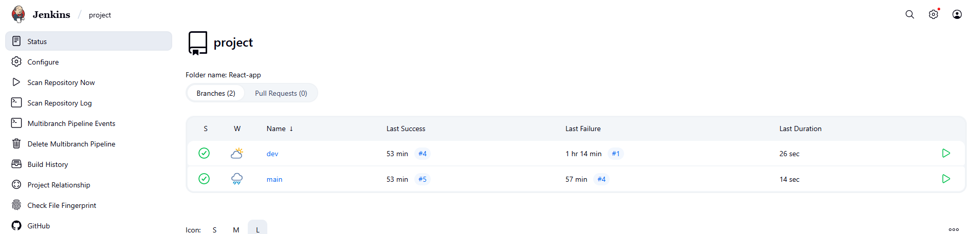

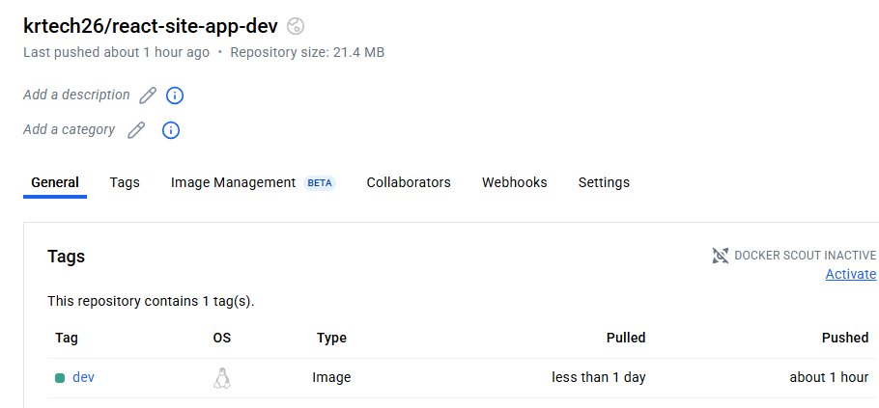

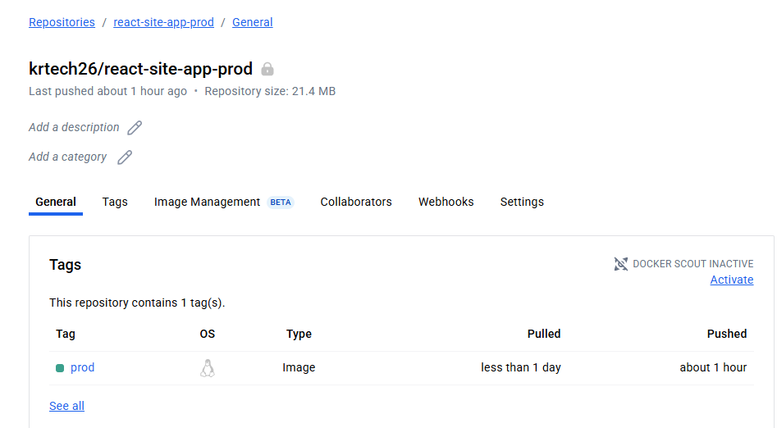

**6.7 If code pushed to dev branch, docker image must build and pushed to dev repo in docker hub**



After changing the code in dev branch, now build triggered using Jenkins file, as per our Jenkins file if code pushed to dev branch, docker image must be build and pushed to dev repo in docker hub, and main branch will be skipped because it didn’t meet the push command.

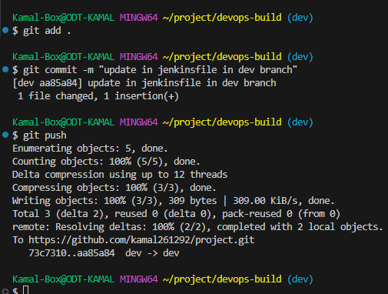

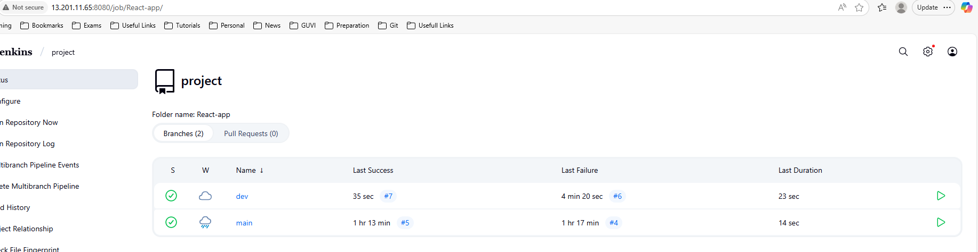



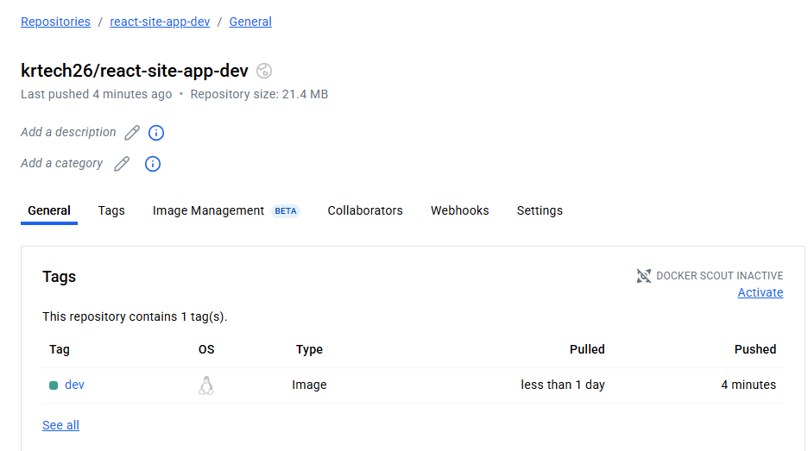

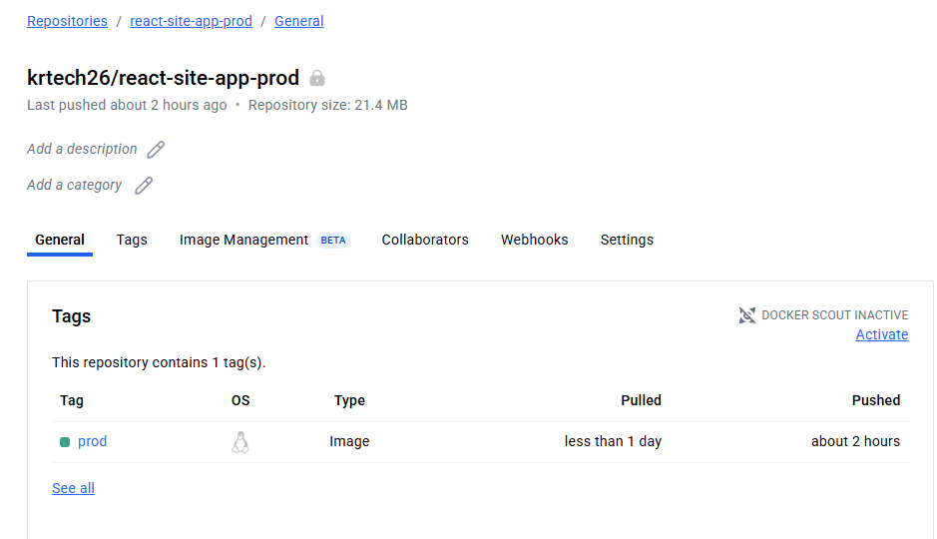

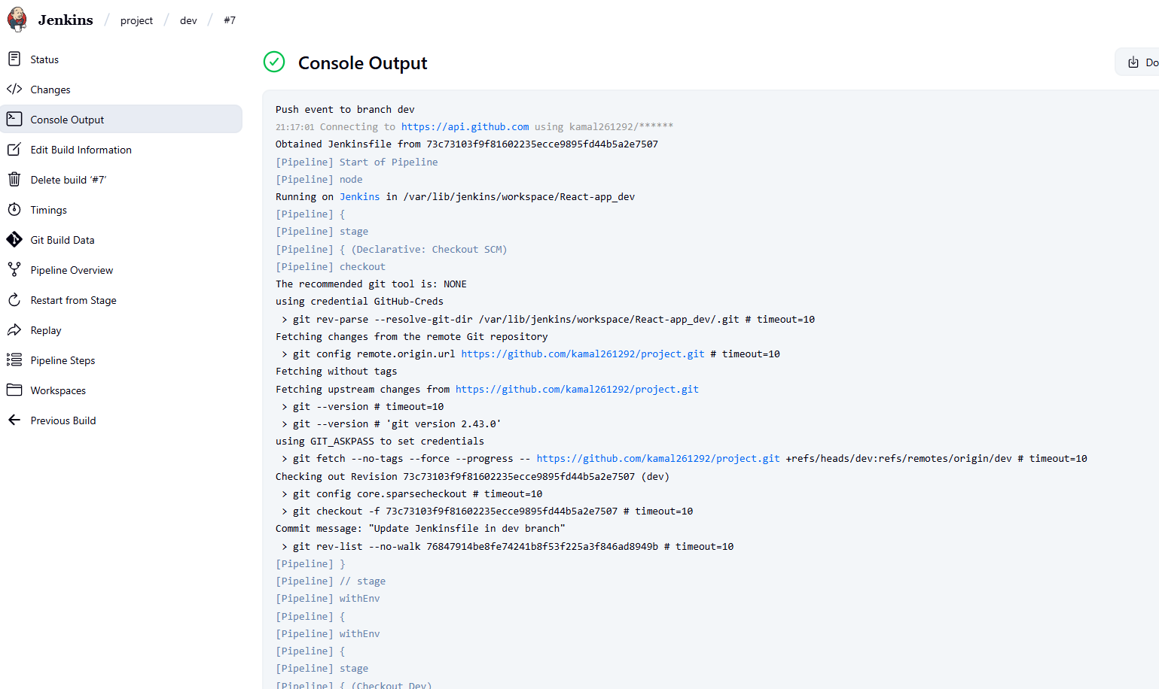 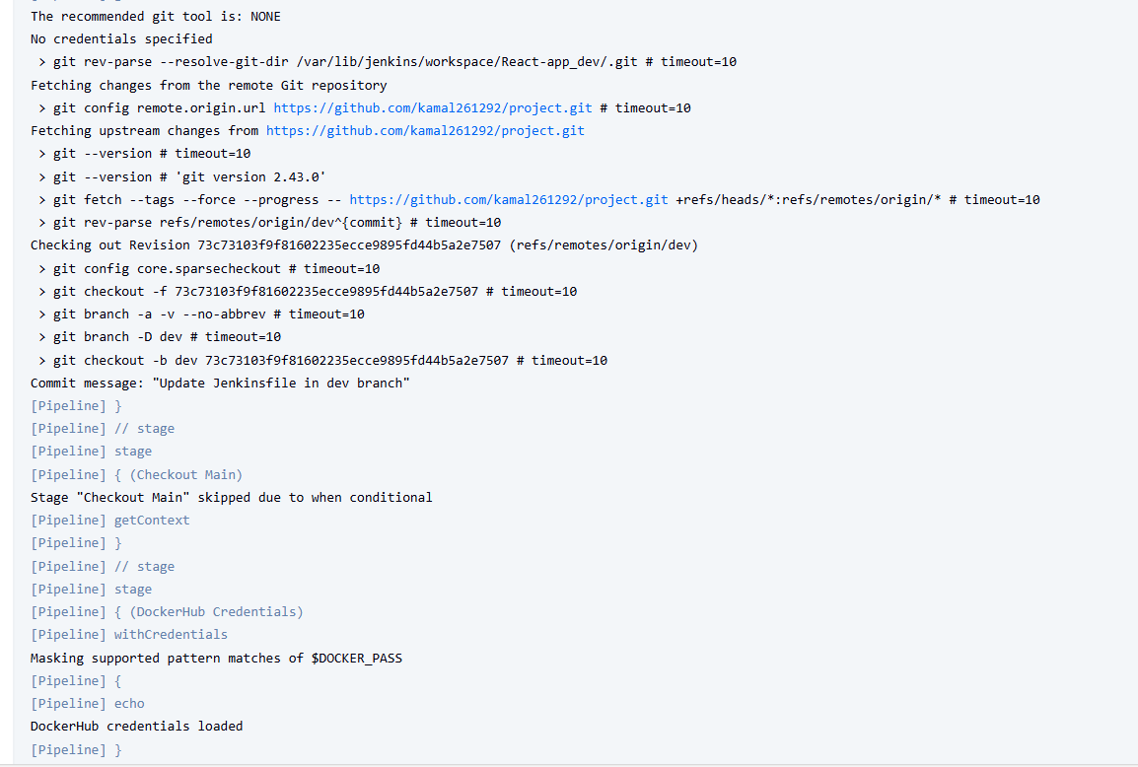



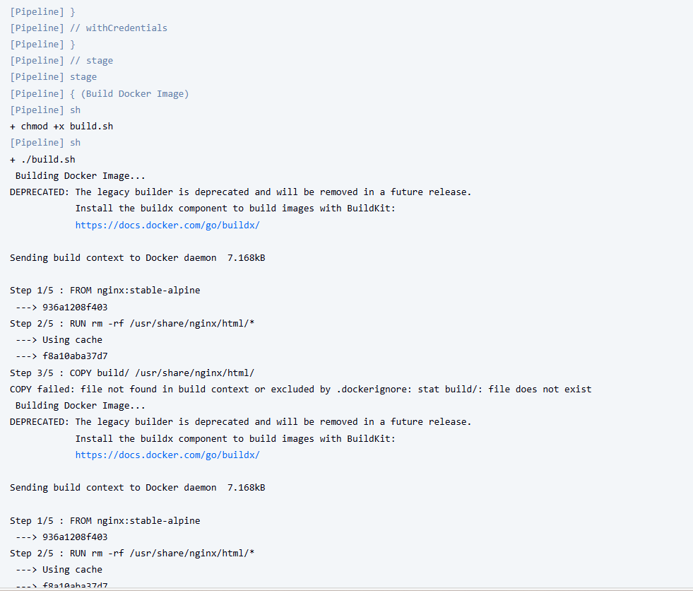 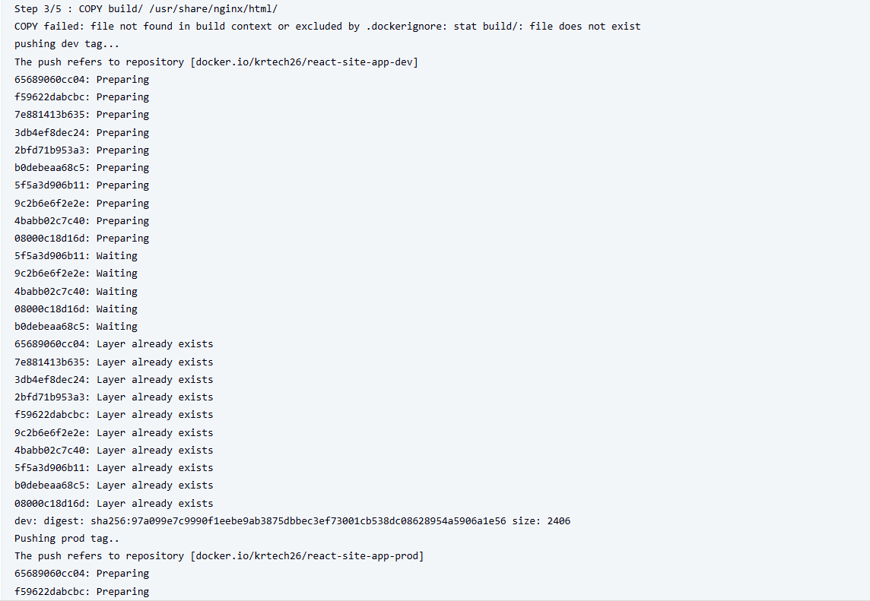 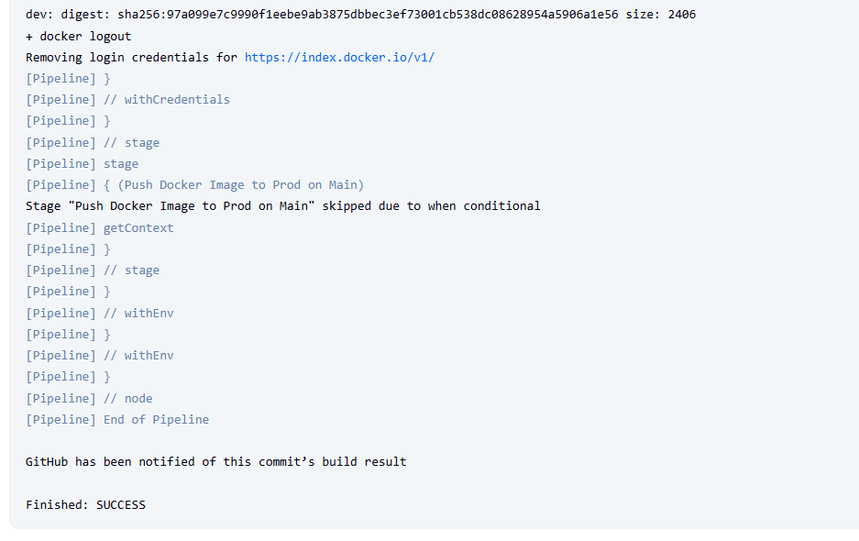



* 1. **Now merge the dev to master (main).**

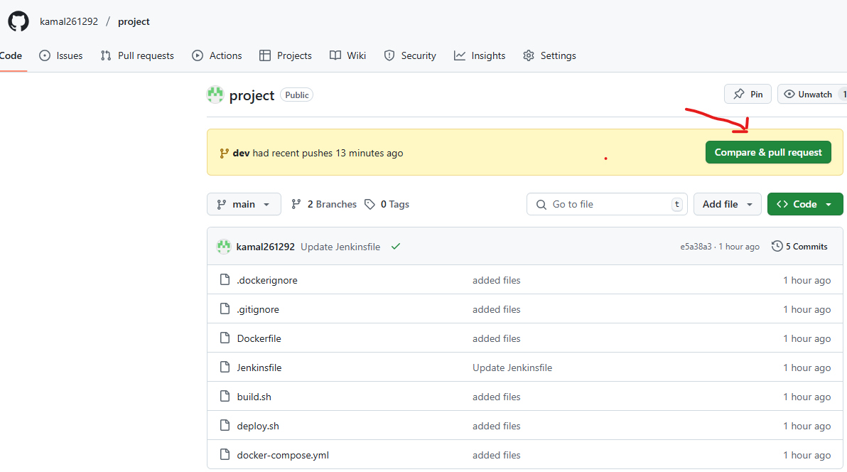

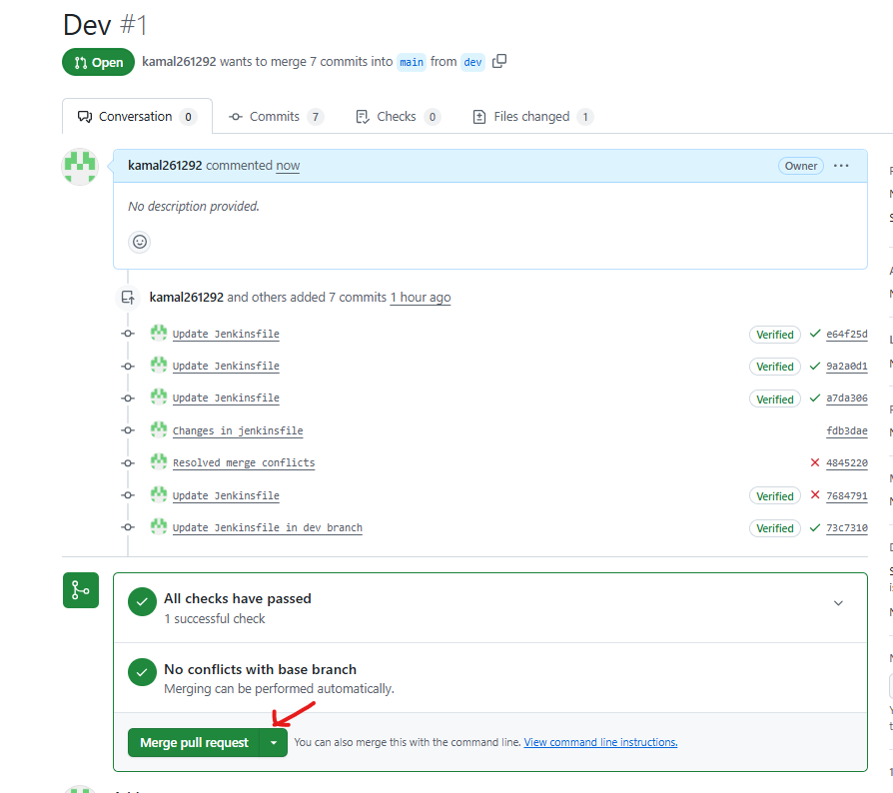

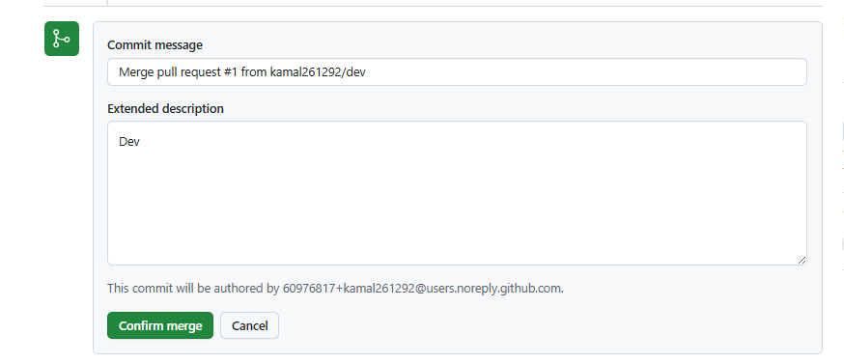

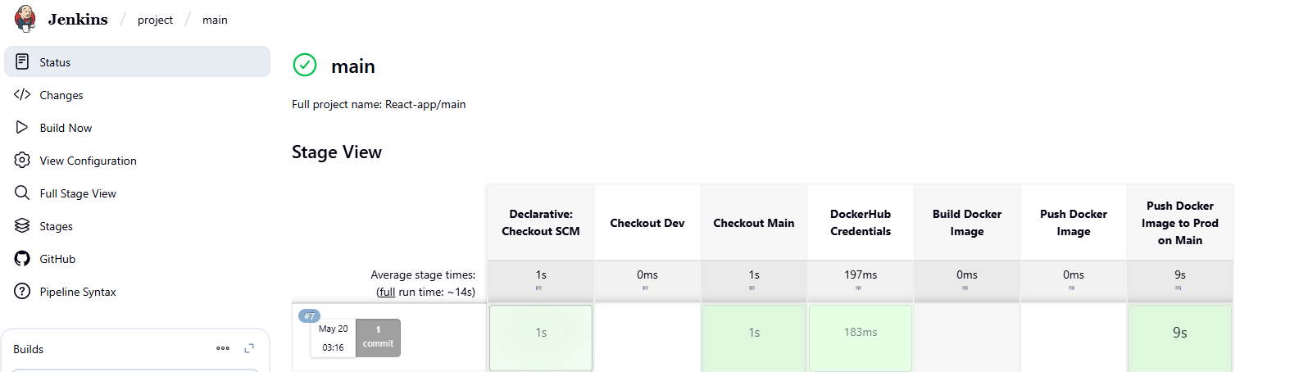

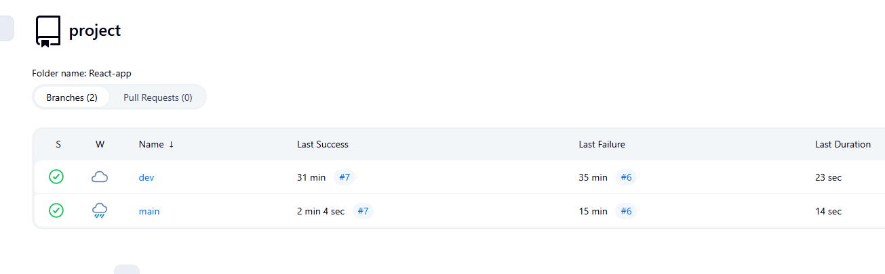

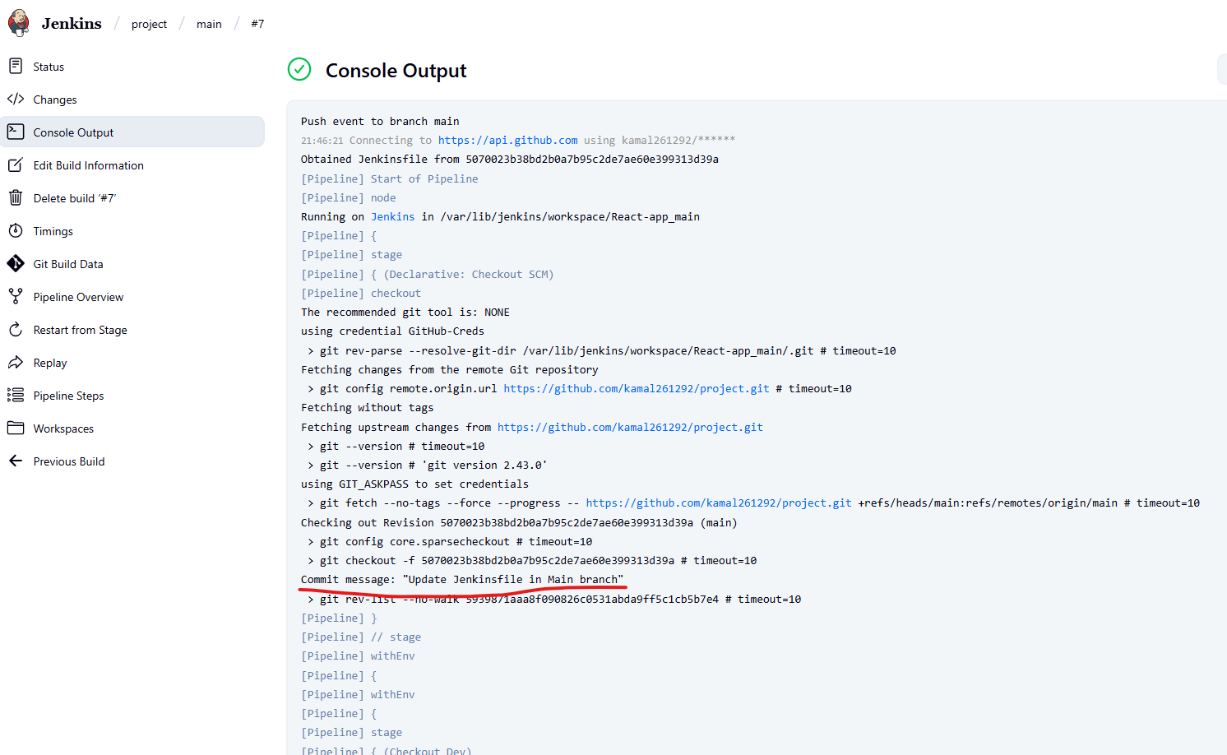 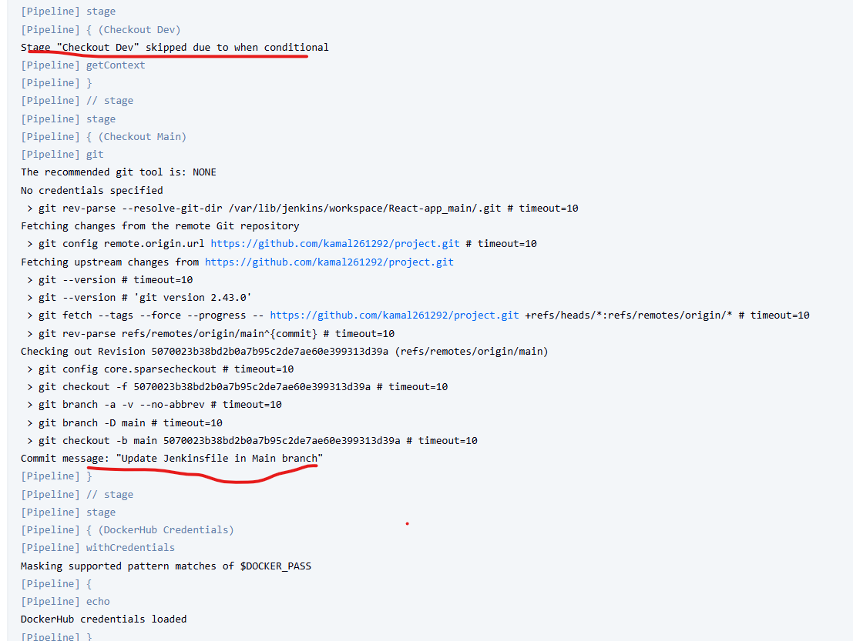

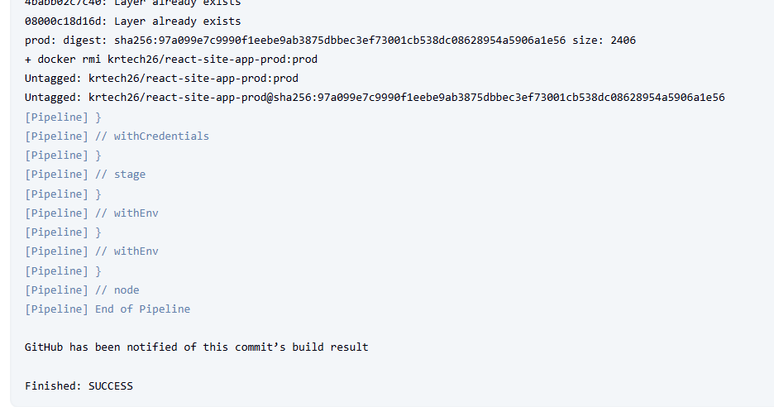

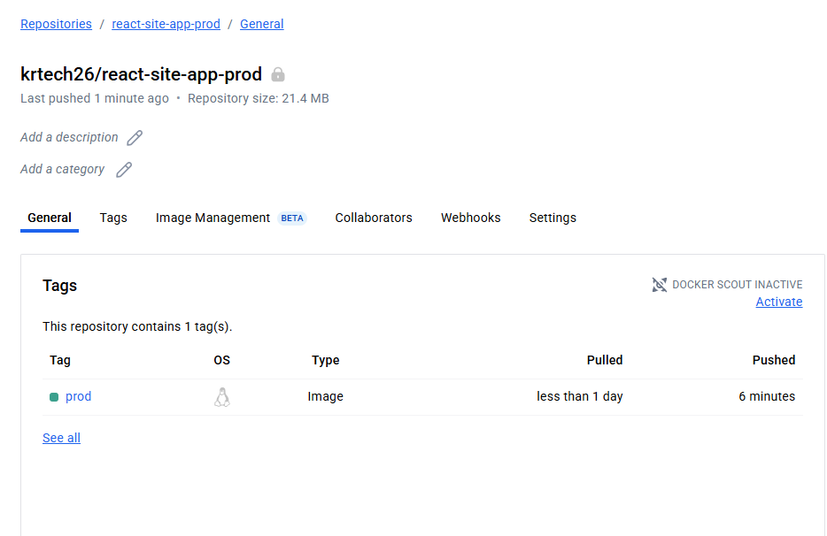

**Step 7: AWS**

7.1 Launch t2.micro instance and deploy the create application

Configure SG as below.

* Whoever has the ip address can access the application
* Login to server can should be made only from your ip address

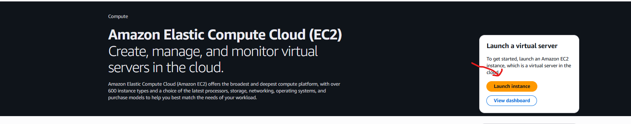

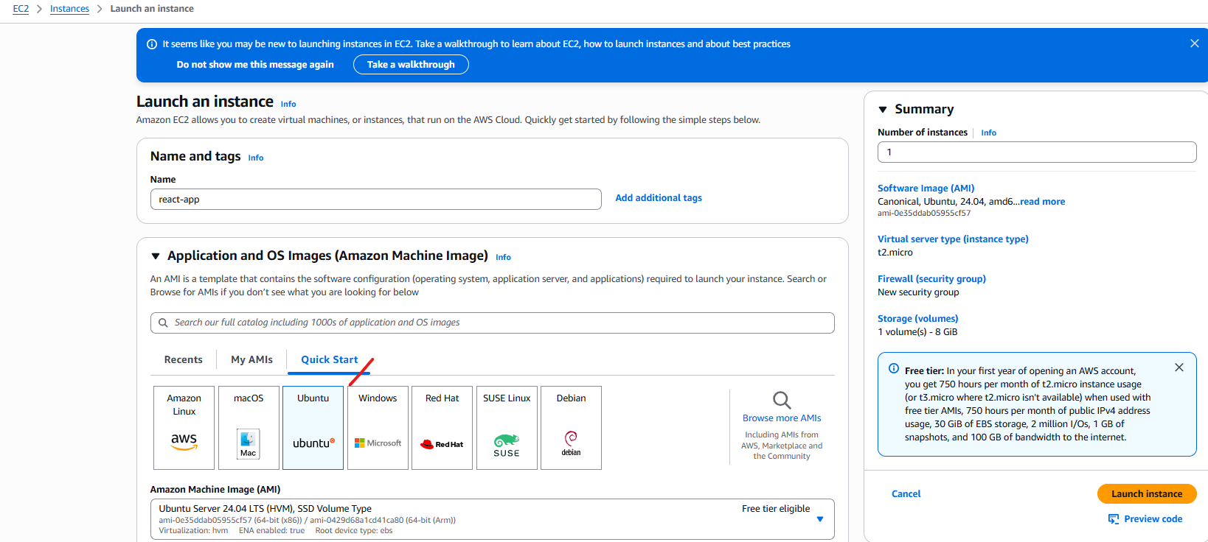

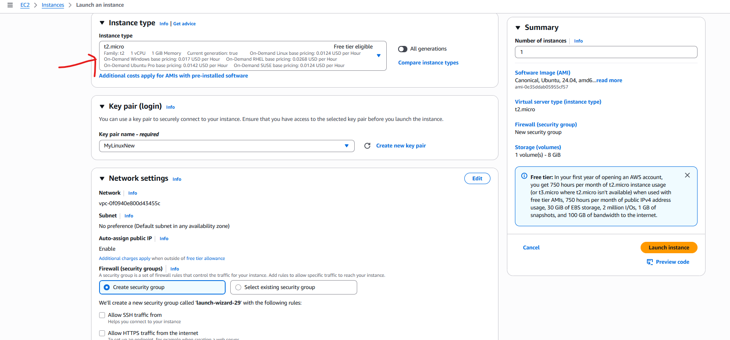

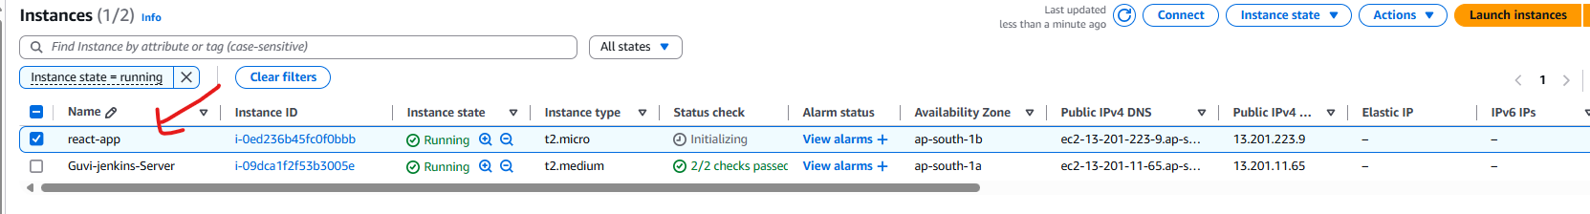

7.2 Now Configure the SG

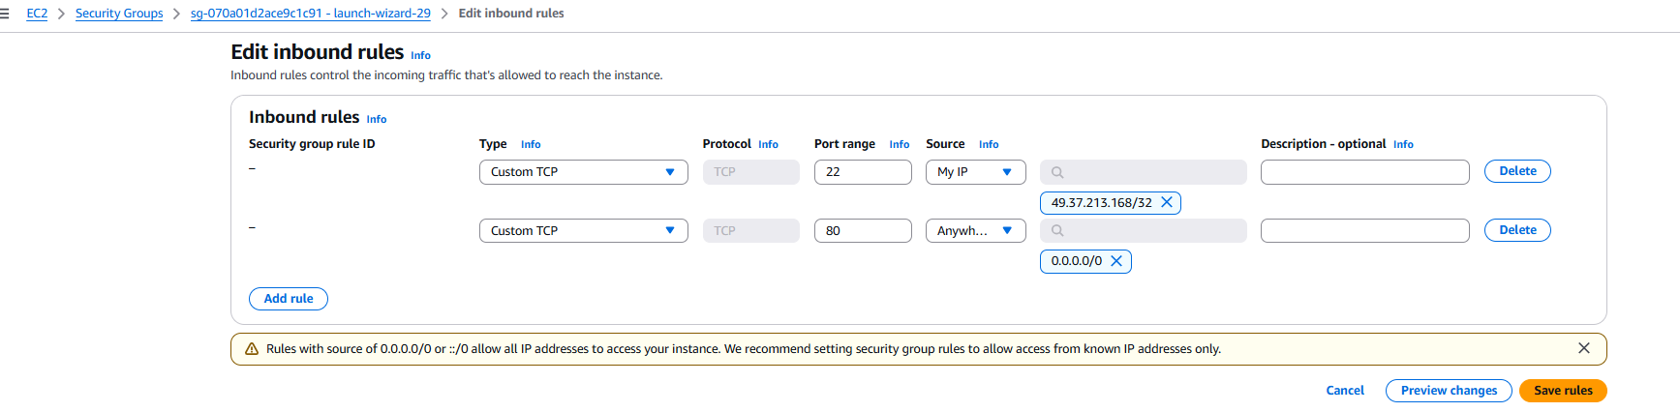

7.3 Now connect to the server using ssh with your ip address.

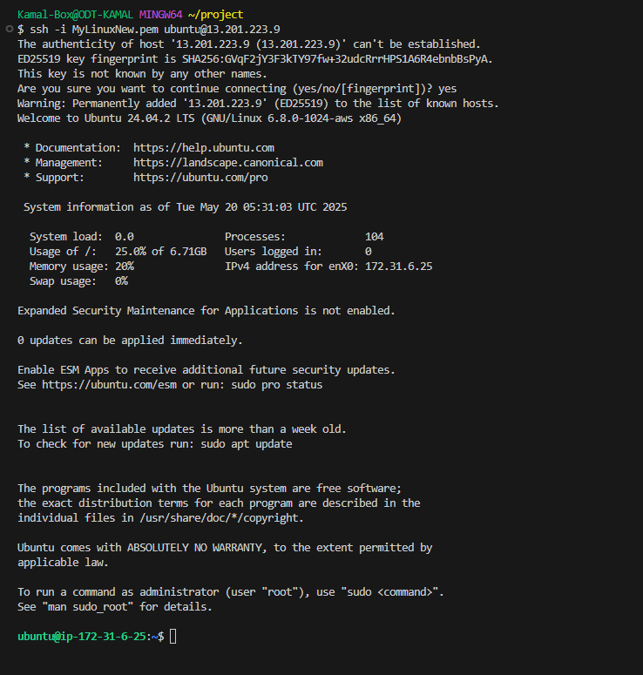

172-31-6-25 is a private ip address of react-app

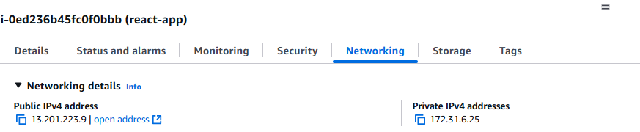

**7.4 Install docker in Ec2 instance**

* sudo apt update -y
* sudo apt install docker -y
* 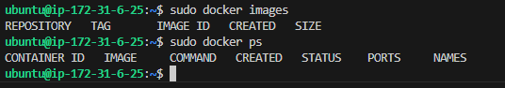
* sudo systemctl start docker
* sudo systemctl enable docker
* sudo usermod -aG docker ubuntu

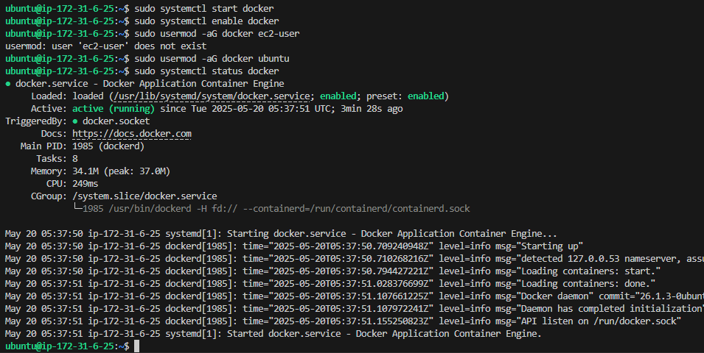

**7.5 Pull & Run our Docker Image from EC2 terminal**

Login into docker hub using credentials. Because we put our prod in private repo.

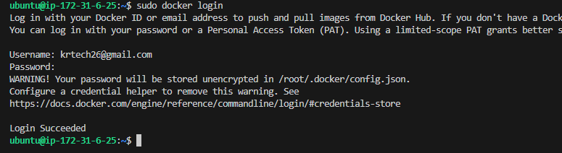

**7.6 Now pull the docker image from our dockerhub repo**

**sudo docker pull krtech26/react-site-app-prod:prod**

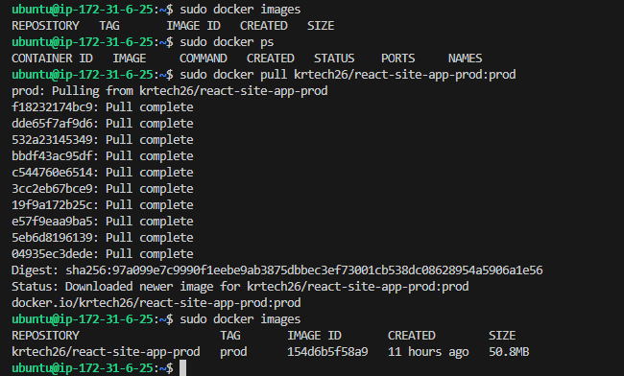

7.7 Now run the react-app application in port 80

**sudo docker run -d -it -p 80:80 --name react-app krtech26/react-site-app-prod:prod**

**sudo docker ps**



7.8 Now site has been reachable from react-app server with the port of **80**. Public IP is **13.201.223.9**

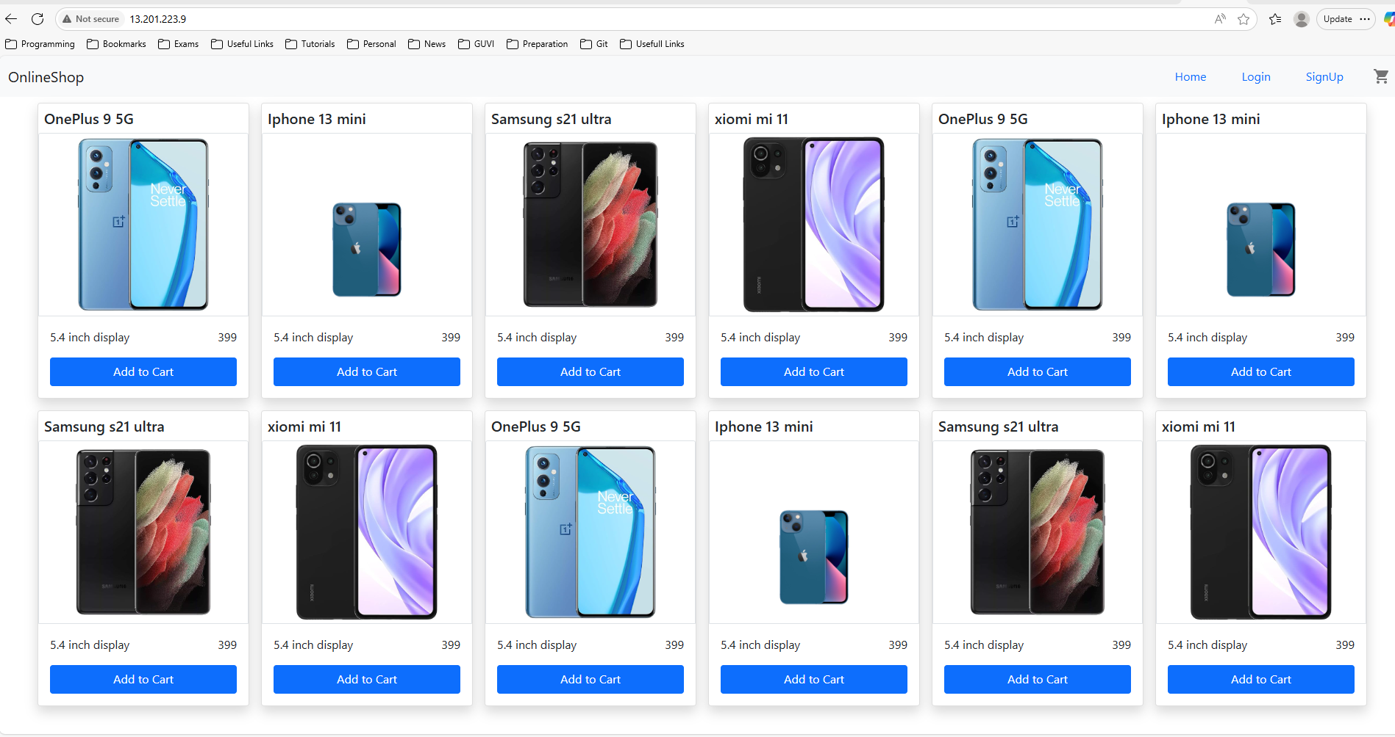

**Step 8: Setup Monitoring for react-app**

As per the requirements.

setup a monitoring system to check the health status of the application

sending notifications only if the application goes down is highly appreciable.

8.1 **Install Node Exporter on the Application EC2 Instance**

Node Exporter will expose metrics about your EC2 instance's health.

1. SSH into your EC2 instance.
2. Create a Prometheus user (best practice for security):

**sudo useradd --no-create-home --shell /bin/false Prometheus**

1. Download Node Exporter: Find the latest version on the Prometheus downloads page.

**wget https://github.com/prometheus/node_exporter/releases/download/v1.7.0/node_exporter-1.7.0.linux-amd64.tar.gz # Check for latest version**

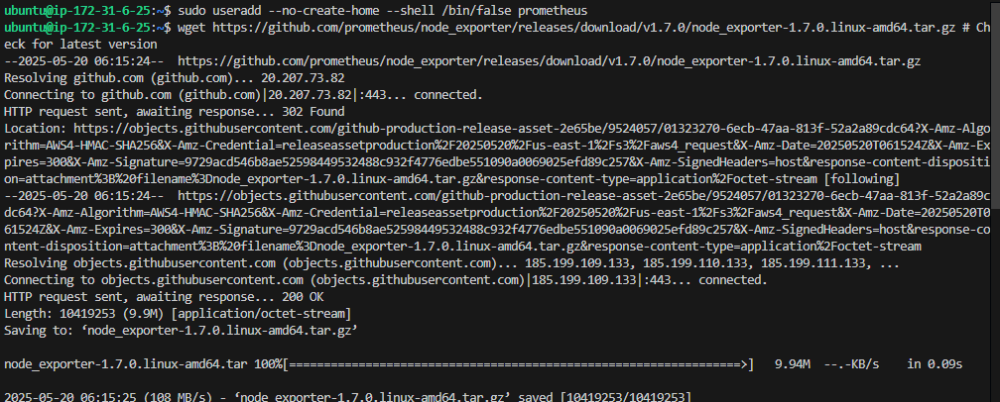

1. Extract and move the binary:

**tar xvf node_exporter-*.linux-amd64.tar.gz**

**sudo mv node_exporter-*.linux-amd64/node_exporter /usr/local/bin/**

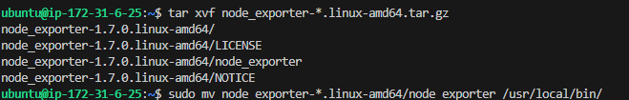

1. Set ownership:

**sudo chown prometheus:prometheus /usr/local/bin/node_exporter**

1. Create a systemd service file for Node Exporter:

**sudo nano /etc/systemd/system/node_exporter.service**

1. Paste the following code.

**```ini [Unit] Description=Node Exporter Wants=network-online.target After=network-online.target [Service] User=prometheus Group=prometheus Type=simple ExecStart=/usr/local/bin/node_exporter [Install] WantedBy=multi-user.target ```**

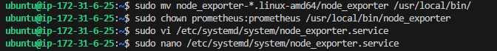

1. Reload systemd, start, and enable Node Exporter:

**sudo systemctl daemon-reload**

**sudo systemctl start node_exporter**

**sudo systemctl enable node_exporter**

**sudo systemctl status node_exporter**

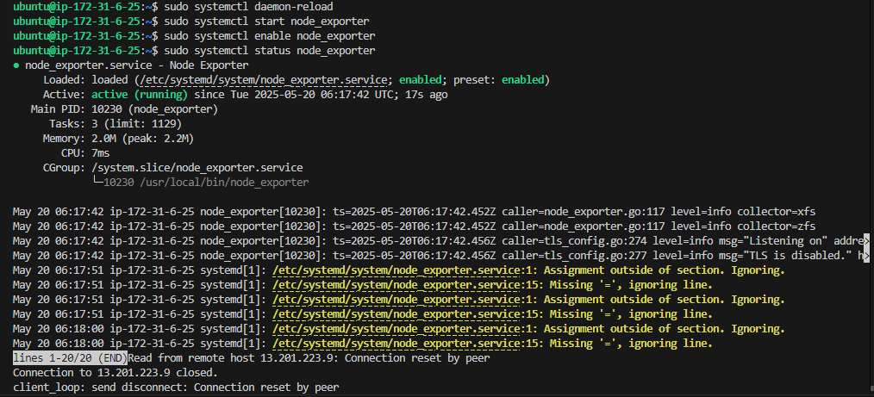

**Verify it's running and listening on port 9100: localhost:9100/metrics**

**Allow port 9100 in SG.**

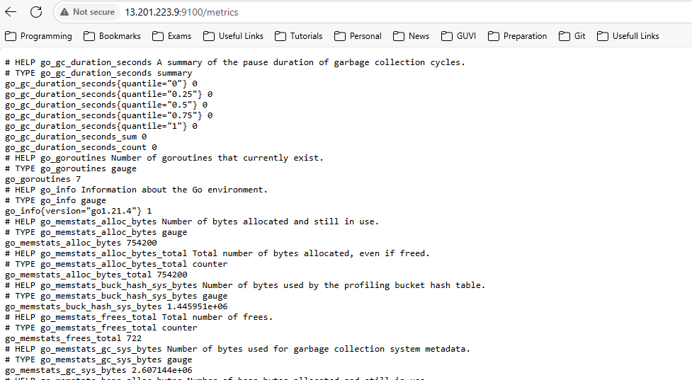

**8.2: Install Prometheus on the EC2 Instance**

1. Create directories for Prometheus:

**sudo mkdir /etc/prometheus**

**sudo mkdir /var/lib/prometheus**

**sudo chown prometheus:prometheus /var/lib/Prometheus**



1. Download Prometheus: Find the latest version on the Prometheus downloads page.

**wget https://github.com/prometheus/prometheus/releases/download/v2.51.0/prometheus-2.51.0.linux-amd64.tar.gz # Check for latest version**

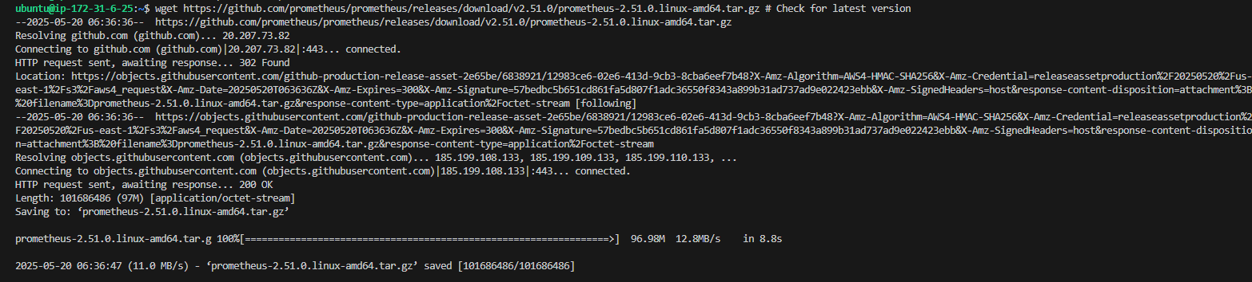

1. Extract and move binaries/console files:

**tar xvf prometheus-*.linux-amd64.tar.gz**

**sudo mv prometheus-*.linux-amd64/prometheus /usr/local/bin/**

**sudo mv prometheus-*.linux-amd64/promtool /usr/local/bin/**

**sudo mv prometheus-*.linux-amd64/consoles /etc/prometheus**

**sudo mv prometheus-*.linux-amd64/console_libraries /etc/Prometheus**

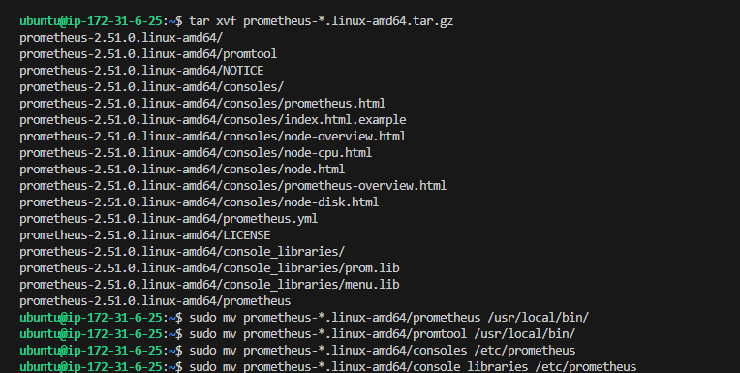

1. Set ownership for binaries:

**sudo chown prometheus:prometheus /usr/local/bin/prometheus**

**sudo chown prometheus:prometheus /usr/local/bin/promtool**

**sudo chown -R prometheus:prometheus /etc/prometheus/consoles**

**sudo chown -R prometheus:prometheus /etc/prometheus/console_libraries**



1. Create prometheus.yml configuration:

sudo nano /etc/prometheus/prometheus.yml

sudo cat /etc/prometheus/prometheus.yml

**global:**

**scrape_interval: 15s # How frequently to scrape targets**

**evaluation_interval: 15s # How frequently to evaluate rules**

**alerting:**

**alertmanagers:**

**- static_configs:**

**- targets: ['localhost:9093'] # Alertmanager default port**

**rule_files:**

**- "alert.rules.yml" # We'll create this later**

**scrape_configs:**

**- job_name: 'prometheus'**

**static_configs:**

**- targets: ['localhost:9090'] # Prometheus itself**

**- job_name: 'node_exporter'**

**static_configs:**

**- targets: ['172.31.6.25:9100'] # Node Exporter**

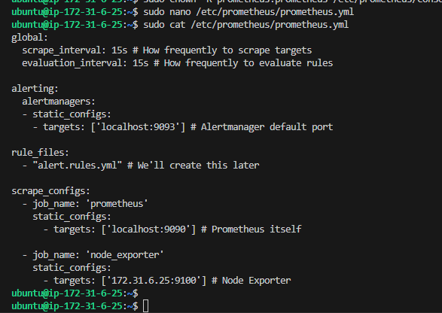

1. Create a systemd service file for Prometheus:

**sudo vi /etc/systemd/system/prometheus.service**

**sudo cat /etc/systemd/system/prometheus.service**

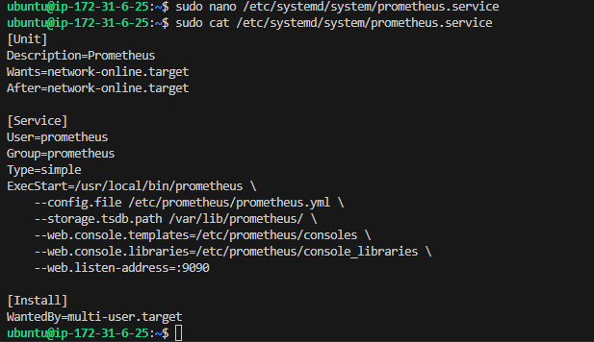

1. Reload systemd, start, and enable Prometheus:

**sudo systemctl daemon-reload**

**sudo systemctl start prometheus**

**sudo systemctl enable prometheus**

**sudo systemctl status Prometheus**

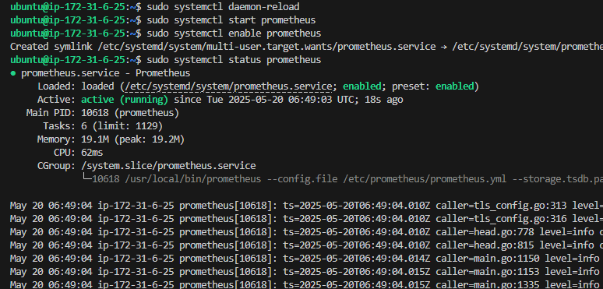

Verify it's running. You should be able to access Prometheus UI via <http://13.201.223.9:9090>.

Allow SG port 9090.

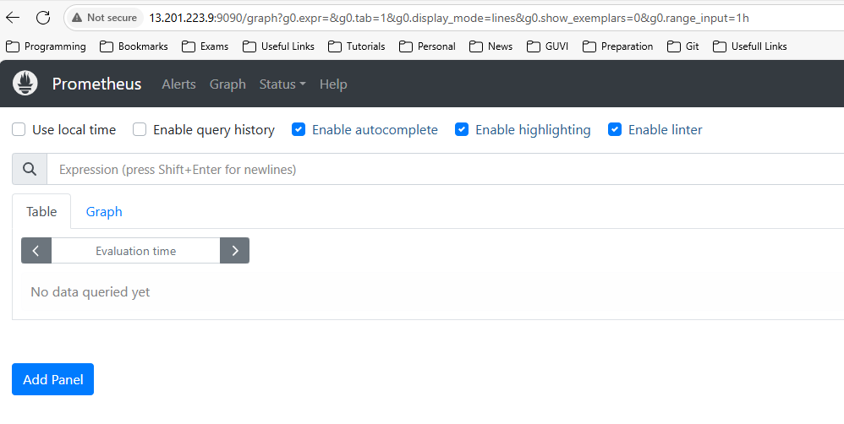

**8.3: Install Alertmanager on the EC2 Instance**

1. Create directories for Alertmanager:

**sudo mkdir /etc/alertmanager**

**sudo mkdir /var/lib/alertmanager**

**sudo chown prometheus:prometheus /var/lib/alertmanager**



2. Download Alertmanager: Find the latest version on the [Prometheus downloads page](https://www.google.com/search?q=https://prometheus.io/download/%23alertmanager).

**wget https://github.com/prometheus/alertmanager/releases/download/v0.27.0/alertmanager-0.27.0.linux-amd64.tar.gz # Check for latest version**

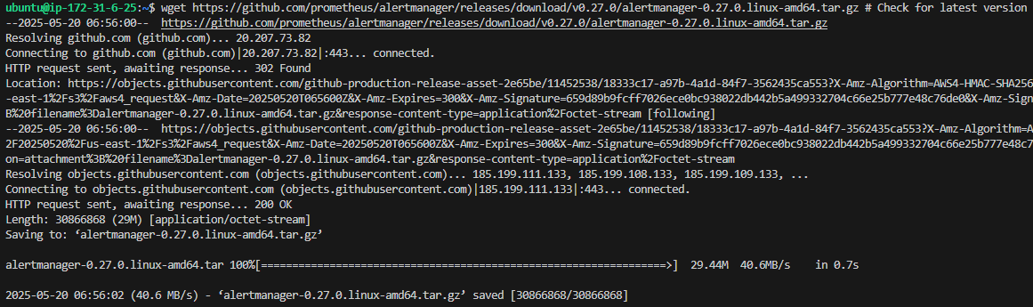

1. **Extract and move binaries:**

**tar xvf alertmanager-*.linux-amd64.tar.gz**

**sudo mv alertmanager-*.linux-amd64/alertmanager /usr/local/bin/**

**sudo mv alertmanager-*.linux-amd64/amtool /usr/local/bin/**

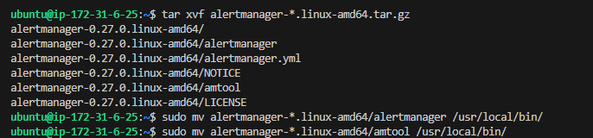

1. **Set ownership:**

**sudo chown prometheus:prometheus /usr/local/bin/alertmanager**

**sudo chown prometheus:prometheus /usr/local/bin/amtool**



1. **Create alertmanager.yml configuration:**

**sudo nano /etc/alertmanager/alertmanager.yml**

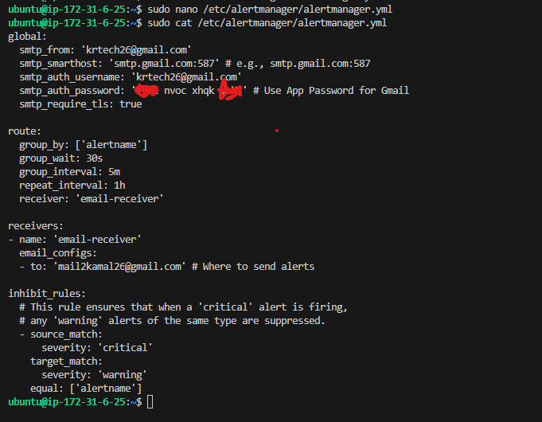

**Create a systemd service file for Alertmanager:**

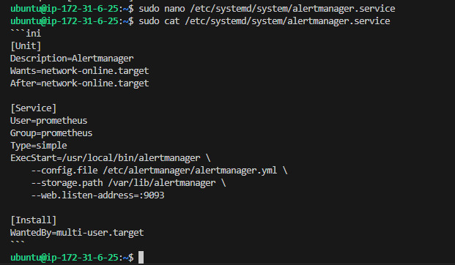

**Reload systemd, start, and enable Alertmanager:**

sudo systemctl daemon-reload

sudo systemctl start alertmanager

sudo systemctl enable alertmanager

sudo systemctl status alertmanager

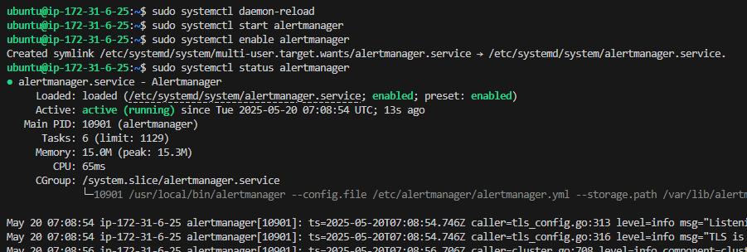

**8.4: Configure Prometheus Alerts (alert.rules.yml)**

Create the alert rules file:

sudo vi /etc/prometheus/alert.rules.yml

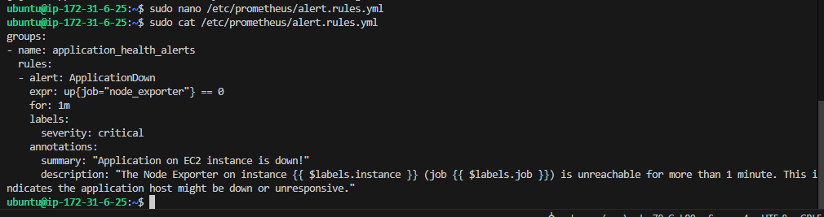

Reload Prometheus to pick up the new rules:

sudo systemctl restart Prometheus

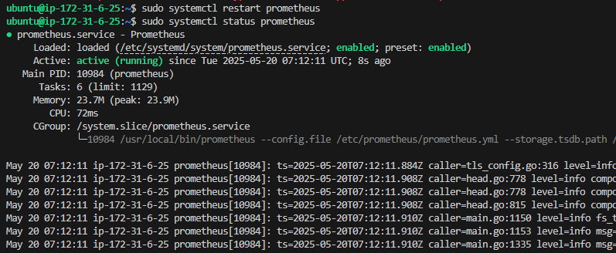

**8.5: Install Grafana on the EC2 Instance**

Add Grafana GPG key:

sudo wget -q -O /usr/share/keyrings/grafana.key <https://apt.grafana.com/gpg.key>

Add Grafana repository:

echo "deb [signed-by=/usr/share/keyrings/grafana.key] https://apt.grafana.com stable main" | sudo tee /etc/apt/sources.list.d/grafana.list



Update apt cache and install Grafana:

sudo apt update && apt install Grafana

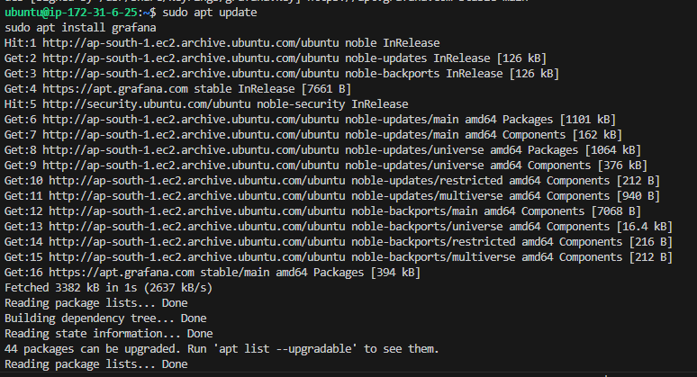

Start and enable Grafana:

**sudo systemctl daemon-reload**

**sudo systemctl start grafana-server**

**sudo systemctl enable grafana-server**

**sudo systemctl status grafana-server**

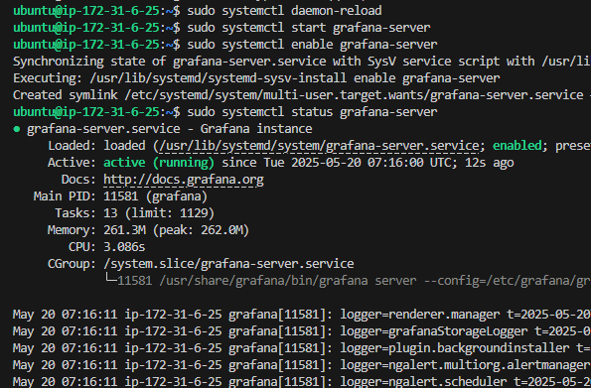

**8.6: Configure Grafana**

Grafana runs on port 3000 by default. Allow port 3000 in SG.

By default, username ‘admin’ and password ‘admin’

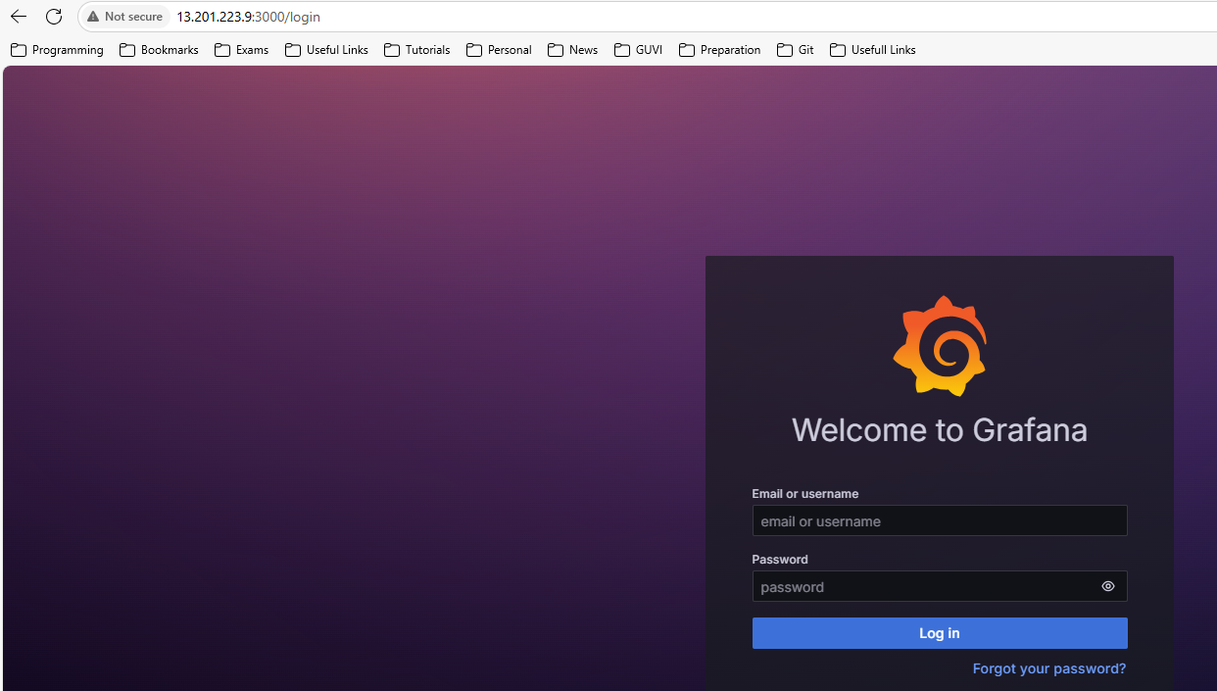

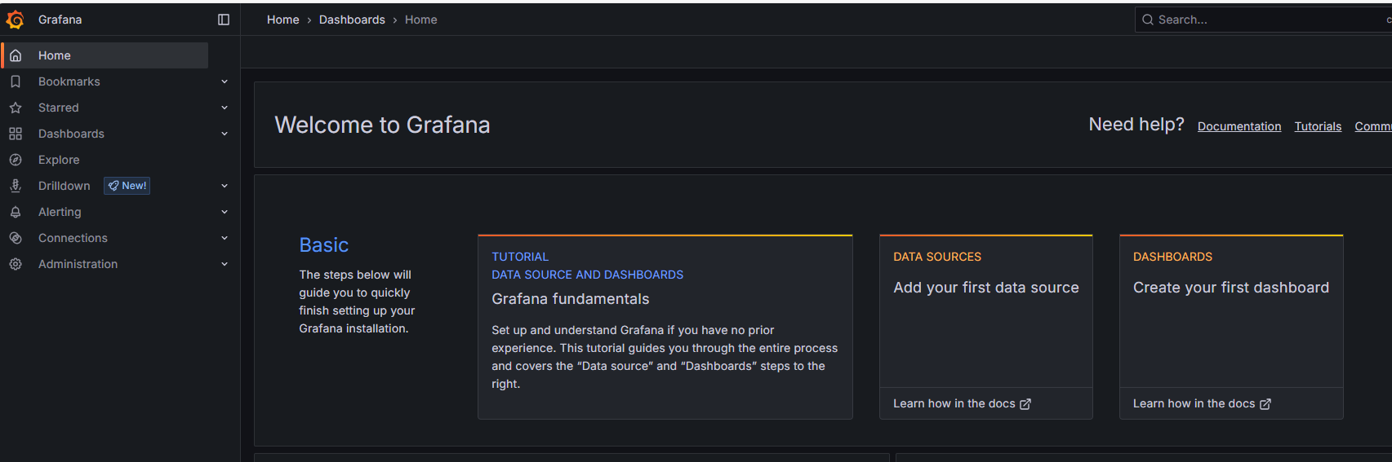

**Add Prometheus Data Source:**

* **Click on the gear icon (Configuration) -> "Data Sources".**
* **Click "Add data source".**

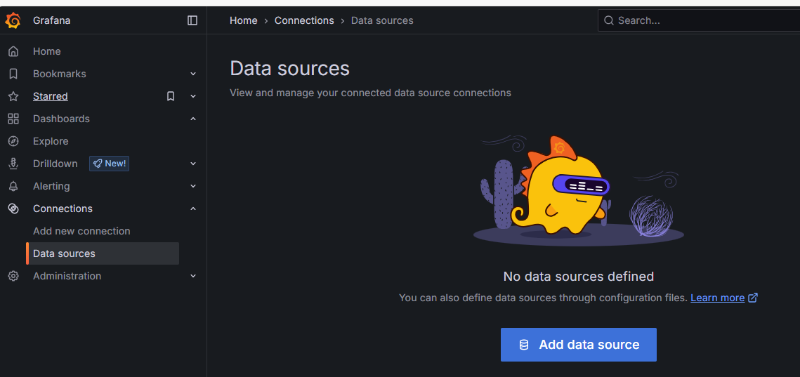

* **Select "Prometheus".**
* **Name: Prometheus (or whatever you prefer)**
* **URL: http://localhost:9090 (since Prometheus is on the same instance)**
* **Scroll down and click "Save & Test". You should see "Data source is working".**

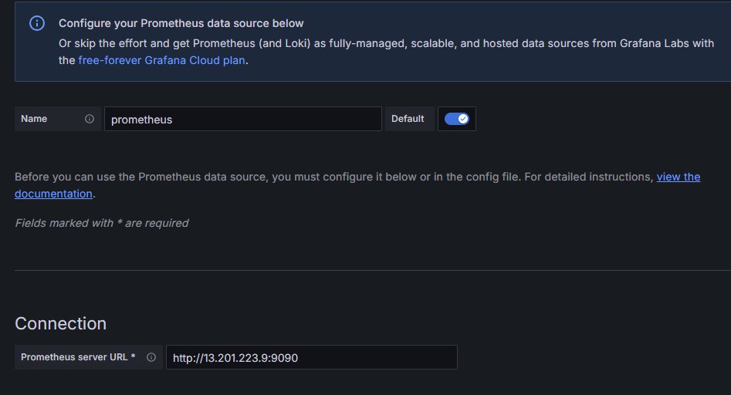

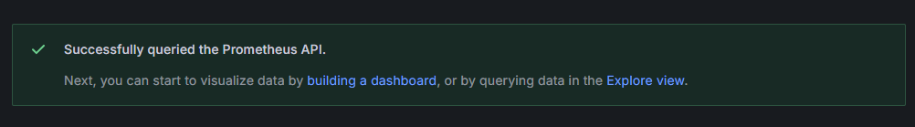

**Create a Dashboard for Application Health:**

* **Click on the '+' icon -> "Dashboard".**
* **Click "Add new panel".**
* **In the "Query" tab:** 
  + **Data source: Select your Prometheus data source.**
  + **Metric browser: Type up and select up{job="node_exporter"}.**
  + **Panel Title: "Application Health Status"**
  + **Visualization: You can choose "Stat" or "Gauge" for a simple health indicator.**
  + **For a "Stat" panel, you might want to map values:** 
    - **Add a value mapping: Value = 1 -> Text = UP, Color = green**
    - **Add a value mapping: Value = 0 -> Text = DOWN, Color = red**
* **Click "Apply".**
* **Save your dashboard.**

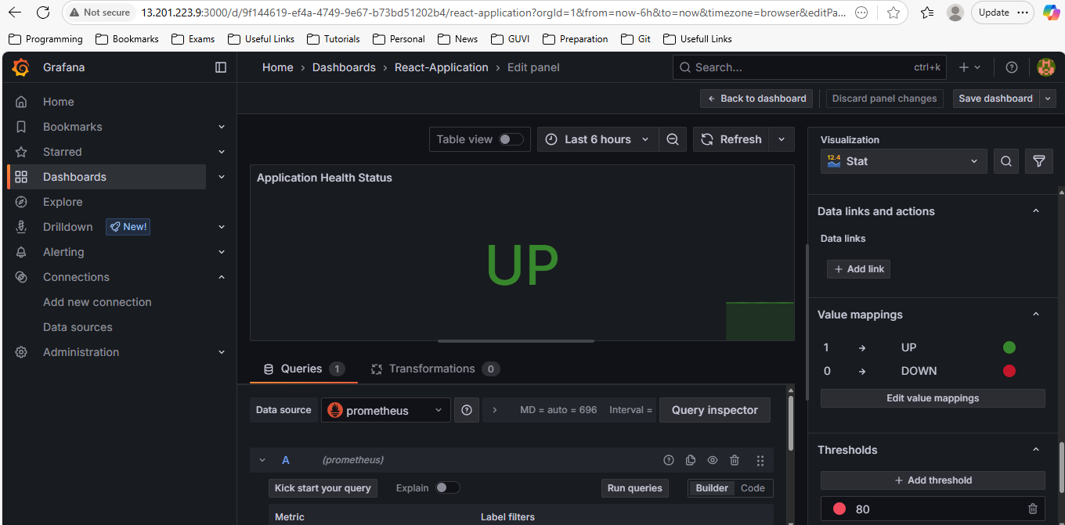

**8.9 EC2 Security Group Configuration**

Make sure you allow the ports for the necessary tools/services.

Inbound Rules:

* Type: Custom TCP | Port Range: 9090 | Source: My IP (or 0.0.0.0/0 - *For Prometheus UI*
* Type: Custom TCP | Port Range: 9093 | Source: My IP (or 0.0.0.0/0) - *For Alertmanager UI*
* Type: Custom TCP | Port Range: 3000 | Source: My IP (or 0.0.0.0/0) - *For Grafana UI*
* Type: Custom TCP | Port Range: 9100 | Source: Internal (Prometheus instance IP or Security Group ID) - *For Node Exporter*

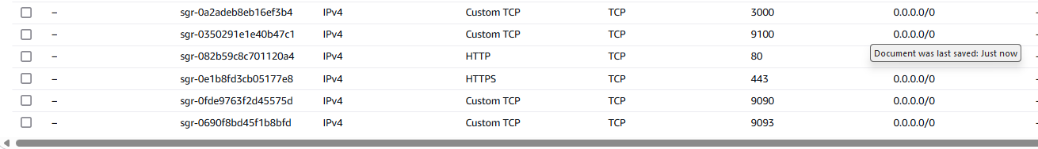

**8.10 Finally test the notifications system.**

**Stop Node Exporter on your EC2 instance:**

**sudo systemctl stop node_exporter**

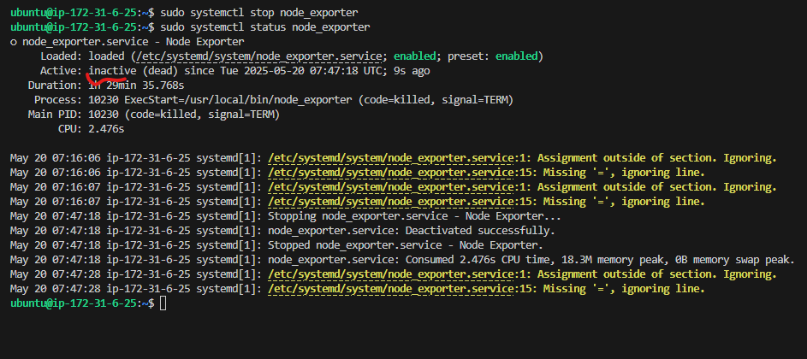

**Received email from source to target emails.**

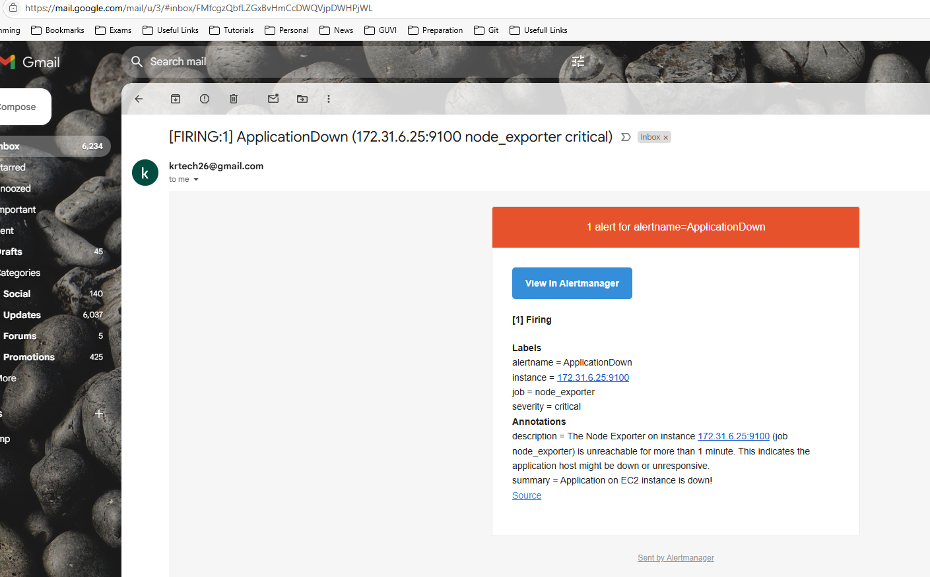

**Node Exporter status in Prometheus**

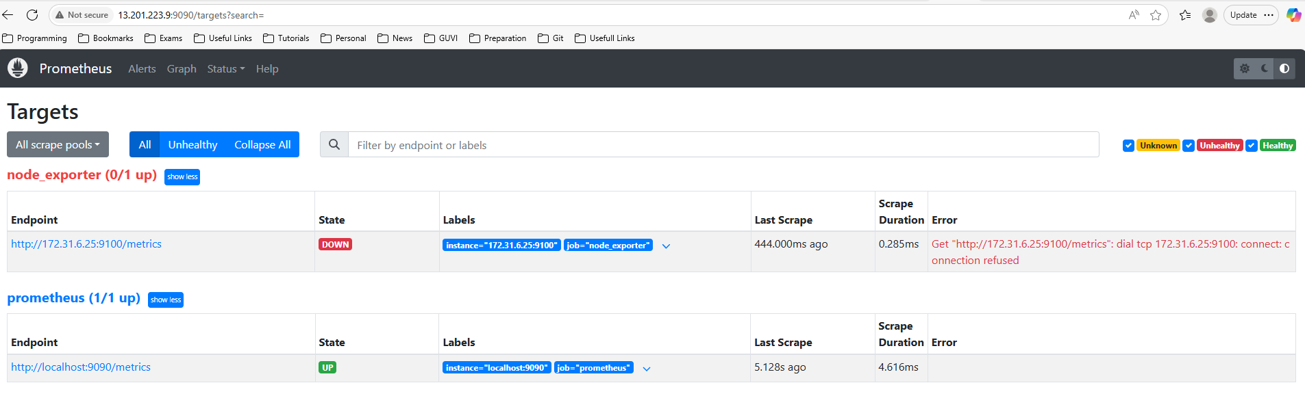

**Service status in Grafana**

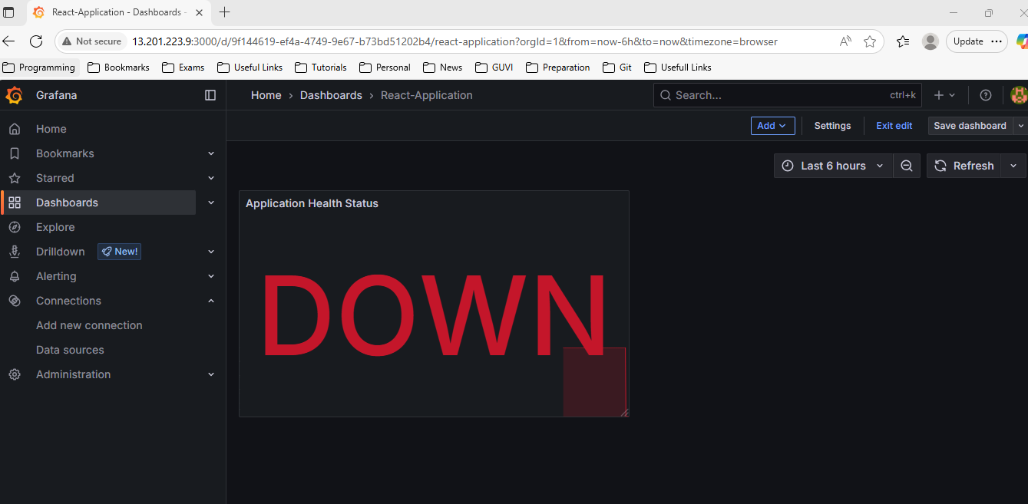

**Now start the node exporter again.**

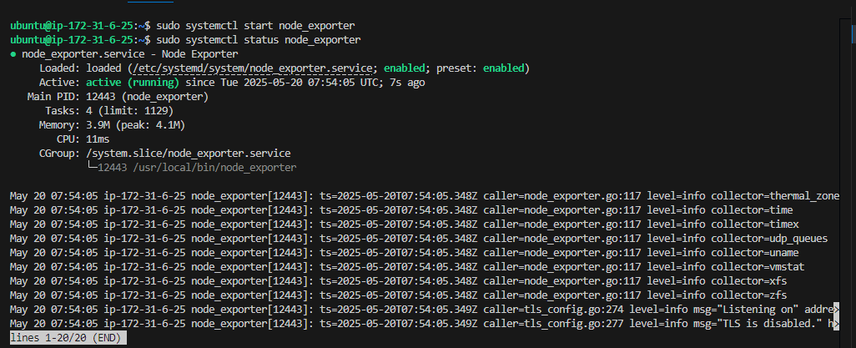

**Node Exporter status in Prometheus**

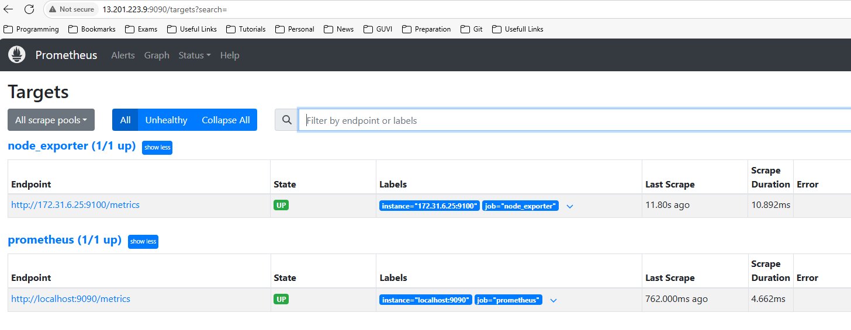

**Service status in Grafana**

